IO 1 - Stereotypes analysis and good practices to break them down
This output is the result of the first phase of the partnership's work. An analysis grid will be prepared (which will be shared during the first transnational meeting) through which each partner will carry out an analysis of the presence of stereotypes within formal learning contexts (schools, training organizations, etc.) informal and non-informal formal (places of aggregation of young people, working environments, associations, etc.) through the support of educators. A meeting with the preliminary educators will be carried out (see the paragraph dedicated to the implementation of the project) during which the path drawn by the project and the analysis grid will be illustrated. At the end of the analysis, the results will be shared and discussed and the recurring stereotypes identified both among young people and among the educators themselves (conscious and unconscious type). The analysis grid will be the result of the work of the psychologists who make up the resources of the partnership. It will be tested beforehand with a sample of educators and students (chosen according to common criteria defined and shared among the partners) and subsequently implemented. This tool will not be composed only of questions but also of images, film evocations, stories that will invite the interviewee to reflect on his own idea of ​​male and female gender. The fine tuning and administration of the analysis grid takes a long time, as well as the administration and analysis of the results. Furthermore, at the end of the analysis, the results will be presented and discussed with educators and young people. The recognition of stereotypes will be the fundamental step for their abatement (break down).
This study will lead to the identification of educational and training practices in use that feed the presence of gender stereotypes and the practices that instead combat it.
At the end of this study, the good practices that emerged during the survey will be highlighted and collected in a handbook in each language of the partner countries and in English. The handbook is the innovative element of OI: both the analysis grid and the results will be the result of an original and participated research between educators and young people. The analysis grid, at the end of the survey, will be further refined and made an autonomous product that can be used as a test in any learning context.
The expected impact of this IO is to bring out the conscious and unconscious stereotypes present in each of us that are at the basis of discriminatory attitudes, intolerance and, ultimately, violent behaviour. Furthermore, in the course of returning the results of the analysis which will take place, as indicated, through more meetings with educators and young people, a more informative part will be dedicated to the juridical figures of the working group, where knowledge will be provided on the rights of victims and men of violence (physical, sexual, economic and psychological). In this way we want to raise the level of knowledge (impact) on the subjects of civil and social rights also from the legal point of view (both among young people and among educators) which, as the experience of the partners in this area has shown, they are by no means extensive and known.
During these meetings, the representatives of the Equal Opportunities Department who gave their external support to the project will also be involved.
Lead Organization: Associazione Nazionale Telefono Rosa

What the project foresees…. | Front Activities carried out | Products/number
Questionnaire for the survey | Number of on line and “live” meeting | Numbers of questionnaire
Survey among students, youngsters, | 4 “live” meetings | Numbers of questionnaire: 34
Survey among educators | 2 online and 2 “live” meetings | Numbers of questionnaires: 17
Survey among parents (optional) | Number of on line and “live” meeting | Numbers of questionnaires: 0
Reports of survey | Elaboration of the results and visualization | 1 Handbook with Spanish results in Spanish  1 Handbook with Spanish results in English

HANDBOOK WITH SPANISH RESULTS

1) Methodology of the survey and solutions adopted (facing pandemic period)
The methodology initially proposed changed because of Covid-19. Due to the closure of all the schools in Spain, and after an internal meeting at INCOMA, we decided to send the questionnaire via e-mail attaching a Google form questionnaire to two Vocational Training centres with which we collaborate. However, the response rate obtained was very low.
The reopening of the schools in September gave us the opportunity to contact Vocational Training Centres again. This time the response rate was very positive and from the beginning both schools were very willing to collaborate with the project, so we decided to implement face-to-face sessions. We had two sessions, with students and teachers, per centre with media duration of one and two hours. We also had separate meetings with the co-educators of both centres and tutors of the students.
No active participation from the students' parents has been achieved. The main reason is that we work with Vocational Training centres, which means that there is no AMPA (Associations of Mothers and Fathers of Students, in Spain), and therefore there is no close collaboration between the centres and the parents. Anyway, we tried to send them the questionnaire through the headmasters of the centres, as well as, the students but we have not received any answer.

2) General results of survey
The training sessions were carried out in a centre with Basic VET students (age 16-18) and in another centre with Intermediate VET students (age 19-30). Likewise, when presenting the results and drawing conclusions, it should be borne in mind that in both classes the majority of students were male. In addition, when analysing the results we could observe a great difference between both classes. In general, we could say that Basic VET students responded positively to certain sexist perspectives. Perspectives that on the other hand, we did not see in a generalized way, in the Intermediate Vocational Training students, with the exception of some cases. Therefore, we consider that the factor of age was very relevant in giving these answers.

3) What kind of stereotypes comes from the survey?
CENTER 1:
The first session took place on October 30th in the centre 1. The class was made up of students from Intermediate VET level; all of them were male except for one female. We also had the presence of several teachers from the centre.
We started the first session with the presentation of INCOMA and the UP & UP project and asking students and teachers to fill in the online questionnaire that we had prepared. After that, the meeting continued with a training on stereotypes and gender violence given by an INCOMA worker (psychologist and with work experience in this field). The training ended with a group activity, and the students were very attentive, interested and participative at all times.
The second session started with a short summary of the previous meeting and an activity on gender stereotypes to reinforce the knowledge acquired in the previous session. It is here that a higher number of comments based on stereotypes was observed, a debate arose about women's need to wear certain clothes (e.g. the bra), or the physical capacity of each individual in carrying out domestic activities (e.g. carrying shopping bags). It should be noted that most of the statements with which women and men were identified in the activity were purely cultural, and although they identified them as such, they were the main ones they used when defining one sex and the other.
We continued with the presentation of the results obtained in the questionnaire completed by the students, highlighting the questions that had most caught our attention based on the results.
We focused on the following questions:
- 4. Men are more likely to take science subjects
- 12. Women are more likely than men to make decisions based on their emotions
- 11. Beauty (being attractive) is more important for a girl than for a boy.
After presenting and commenting on these questions we went on to discuss the section of the questionnaire on personal relationships and how much importance the students given to certain aspects. We highlighted the four most voted statements:
- Being understood
- Loyalty
- Respect for others
- Mutual understanding
In order to establish a debate with the students and teachers, we used the Mentimeter tool, so they could continue to give their opinion anonymously. The students were again very participative and involved and celebrated the use of this tool, as it was very interactive.
During the final debate the students shared their own experiences and their point of view of seeing different aspects of relationships today, bringing up issues such as the difference between being loyal and respecting a partner, or their opinions about a very trendy TV programme about couples nowadays in Spain.
CENTER 2:
The first session took place on October 28th in the centre 2. The class was made up of Basic VET students, all of them were male except for one female. We also had the presence of several teachers from the centre. We started the first session with a presentation of INCOMA and the UP & UP project and asking students and teachers to fill in the online questionnaire we had prepared. After this, the meeting continued with a training on stereotypes and gender violence given by an INCOMA worker (psychologist and with work experience in this field). The training ended with a group activity in which we observed that some of the students were more participatory than others and with a different level of involvement. At the end of the session a debate was generated on gender violence and why a law is needed to regulate this phenomenon in Spain.
The second session started with a short summary of the previous meeting and a group activity on gender stereotypes to reinforce the knowledge acquired in the previous session. The main idea was to identify within the characteristics that we usually associate with men and women, which were given by nature and yet influenced by the culture and the environment around us.
We continued with the presentation of the results obtained from the questionnaire completed by the students, highlighting the questions that had most caught our attention based on the results.
We focused on the following questions:
- 16. Women are afraid to take on big responsibilities
- 2. Women are better prepared to raise children than men
- 12. Women are more likely than men to make decisions based on their emotions.
In analysing these questions, several stereotypical comments emerged from students. In general, we can say that from the first question they concluded that this fear of making big decisions can be found in both men and women. Regarding the second question, a discussion was generated among those who believed that women are by nature more prepared to raise children, e.g. because of the bond that is created between mother and child during pregnancy or the possibility for women to breastfeed their children. Other students, on the other hand, thought that whether men or women, they are both prepared to take care of their children. From the last question, a discussion was also generated among those who thought that making decisions based on emotions can be either male’s or female’s behaviour, and that these decisions will depend on the person, their character and how they are with the other person at that moment. Nevertheless, other students defended that women in general are more emotional and can even be more aggressive than men.
We then discussed the section of the questionnaire on personal relationships and how much importance they attached to certain aspects. We highlighted the four most voted statements:
- Solidarity
- Knowing how to always respond to the needs of the other
- Respect for others
- Sexual understanding
We noticed when analysing the results that, although the above mentioned statements were the most voted, almost all the results were around 3 (Neutral). We therefore thought that perhaps students did not identify themselves with any of these statements. So, in order to establish a discussion with students and teachers we thought it would be good to use the Mentimeter tool. The main idea was that they could anonymously comment which values they considered the most important in a relationship. Among the options obtanied, we highlighted the following:
- Laughing together
- Empathy
- That the relationship is not toxic
- Admiration

4) What level of acceptability of gender based violence from the questions?
We focused this question in two main points:
- The acceptance of sexist statements raised from the questionnaires that the students filled in:
It is clear that in the first of the centres where we carried out the activities, the sexist beliefs were less valued, and it could not be concluded whether their answers were based on "social desirability" or on their truly personal criteria. However, on the basis of the results alone we can say that to a large extent they were against the sexist beliefs.
In the case of the second centre, the acceptance of the statements was higher, not positioning themselves as such but neither against it. Given the sexist nature of the statements, any value that does not show explicit disagreement has to be considered sexist, which is why we consider a more sexist approach in this case.
- The opinion that the students showed about the concept of "gender violence":
In this case, the opinions were quite diverse. In the first of the centres we did not find much resistance, although they did not show their agreement or disagreement with the concept of Gender Violence. The exception was one of the students that were openly against the terminology in relation to feminism, saying that it did not clearly identify the equality it seeks by definition.
In the second centre, the resistance to the concept was pretty clear. Several of the students used typical examples ("What if my girlfriend hits me, it's okay", "There are a lot of false allegations because of this law") to defend the irrelevance of a law that combats this social phenomenon. As well as, some students openly showed their feeling of helplessness in the face of similar situations but in the opposite direction. The debate did not last long, and as in the previous case, no consideration was given to the ways in which gender-based violence can be expressed or its forms.

5) Images, screen shot and other visual material collected during the meetings (live and online).
PHOTOS FROM THE SESSIONS
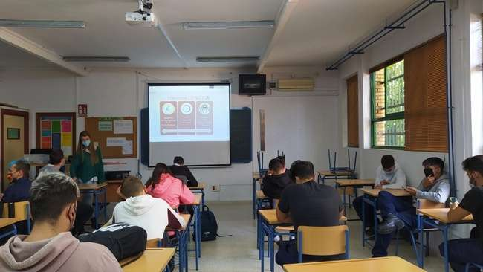
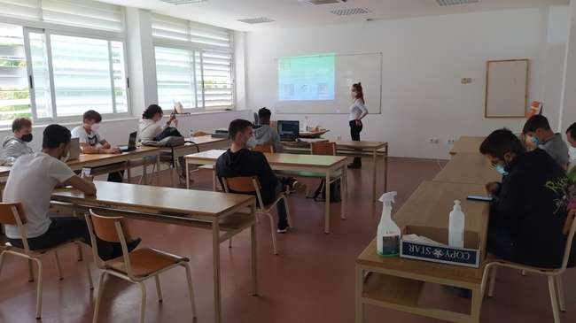

RESULTS MENTIMETER’S ACTIVITY
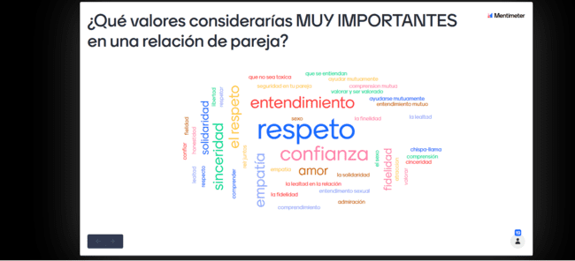
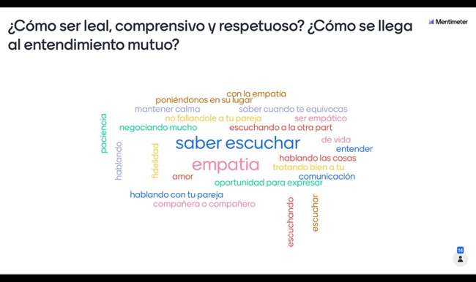

SLIDES USED DURING THE TRAINING SESSIONS
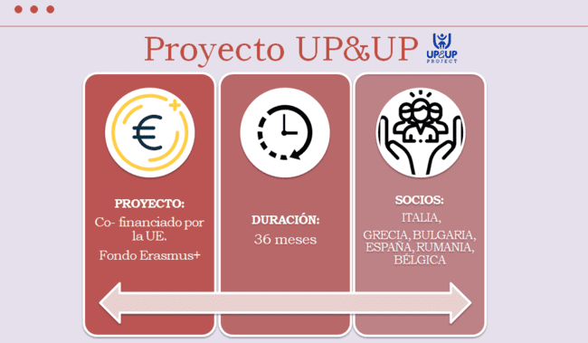
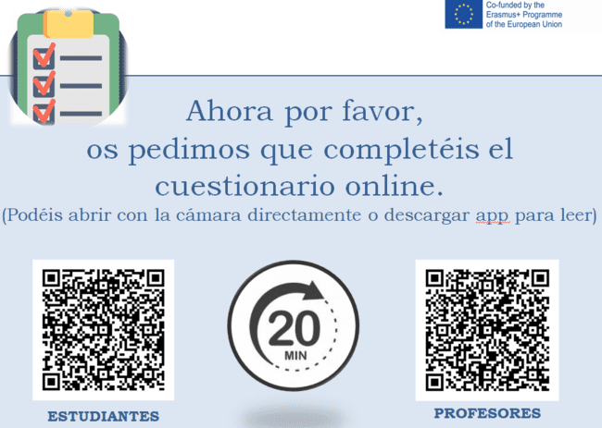

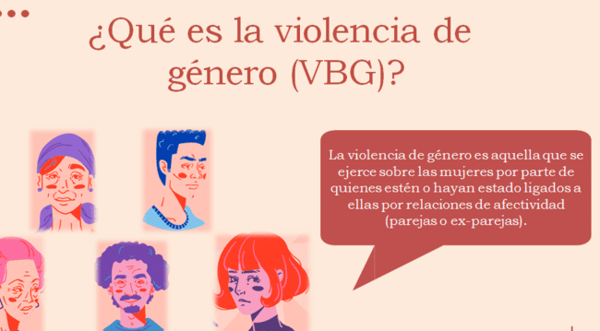
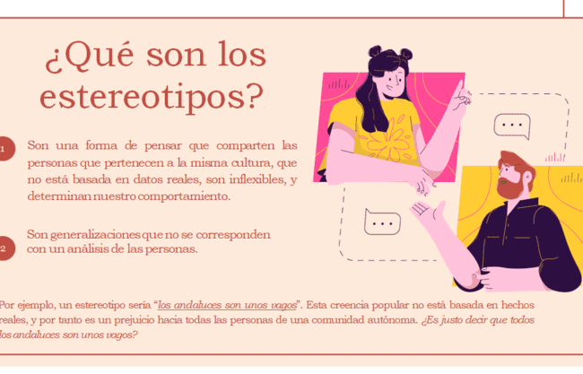

6 Annexes: Graphics obtained from educators’ results (Degree of agreement with the statements being 1 Totally Agree and 5 Totally Disagree; perceived response from students)

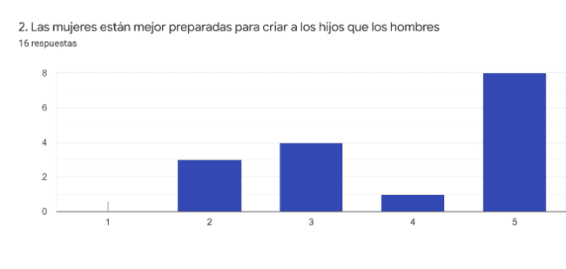
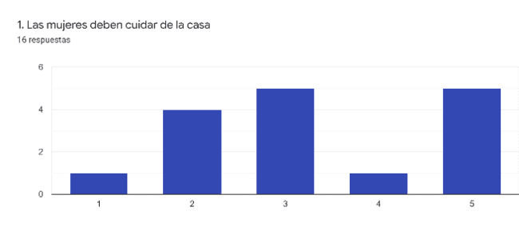
EDUCATORS
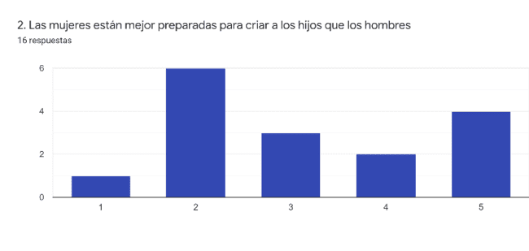
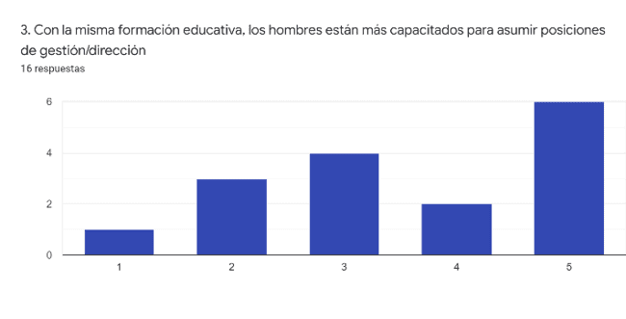
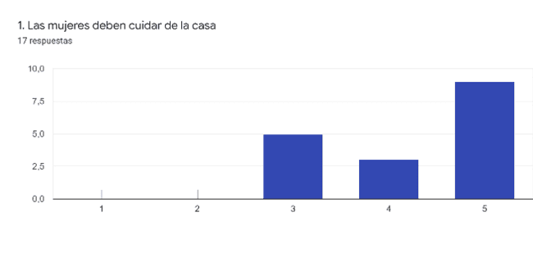
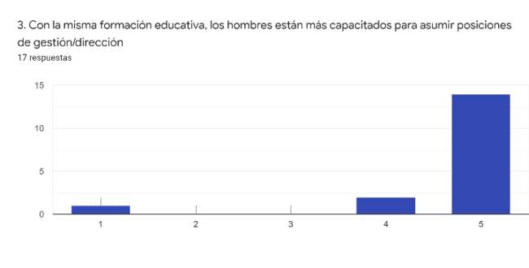
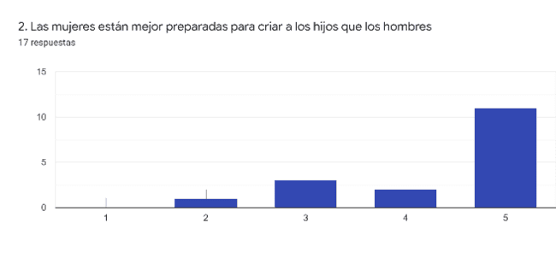
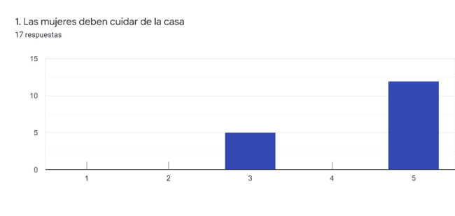
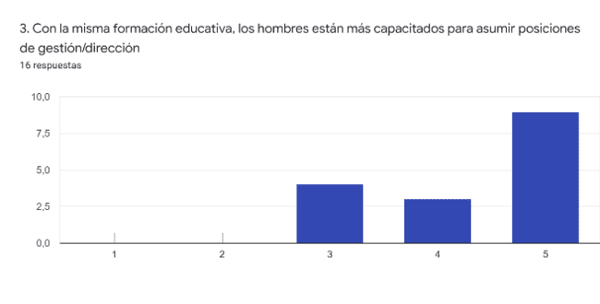
ABOUT FEMALE STUDENTS ABOUT MALE STUDENTS
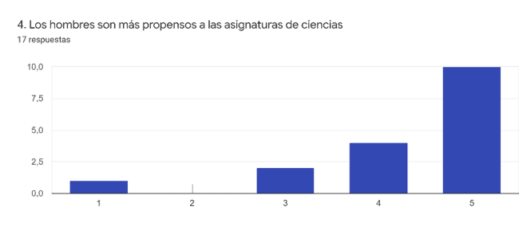
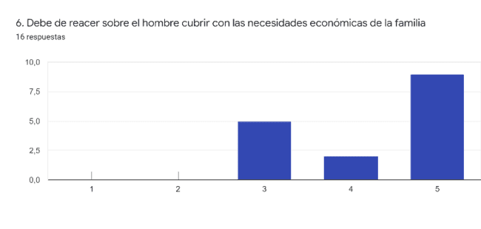
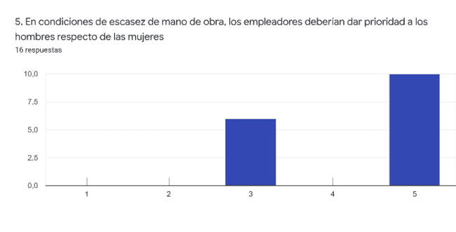
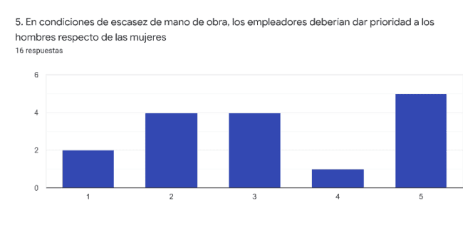
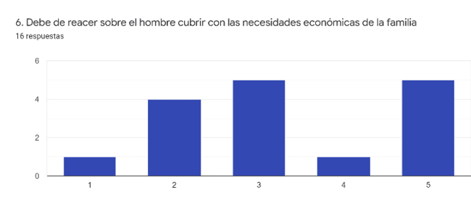
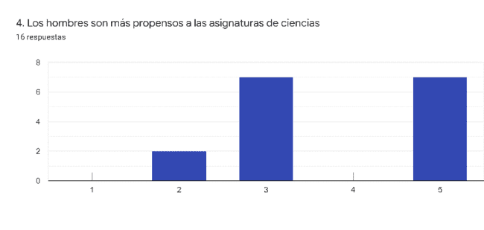
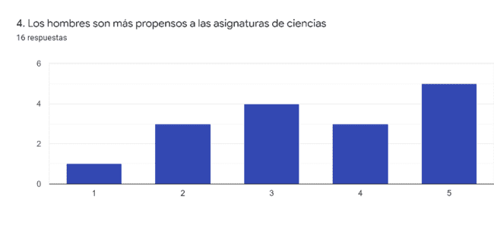
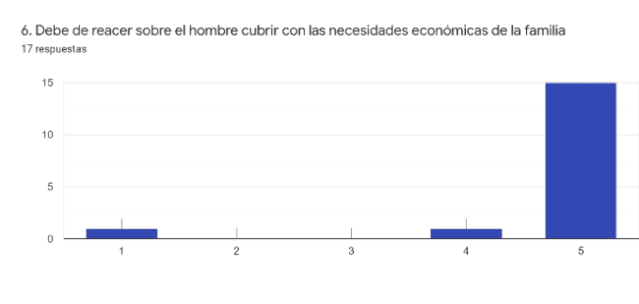
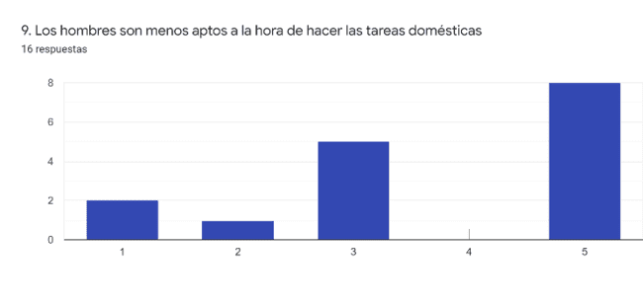
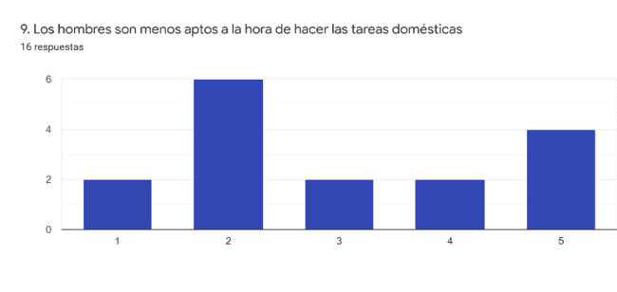
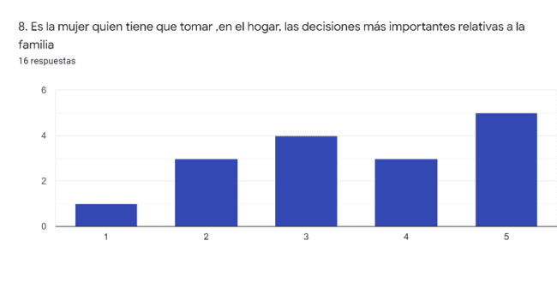
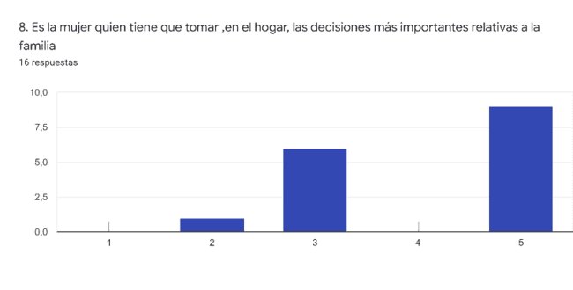
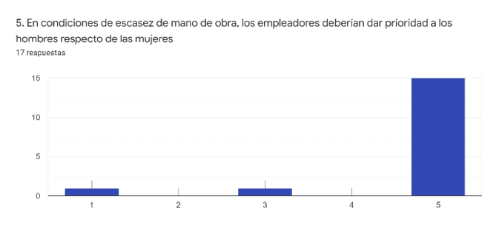
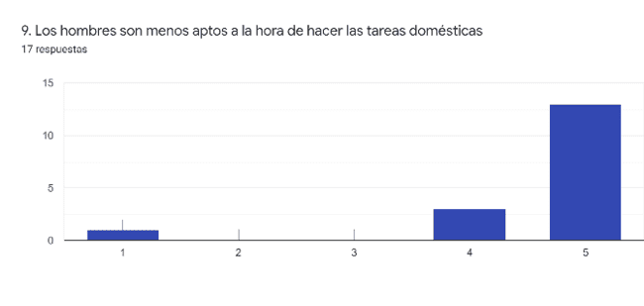
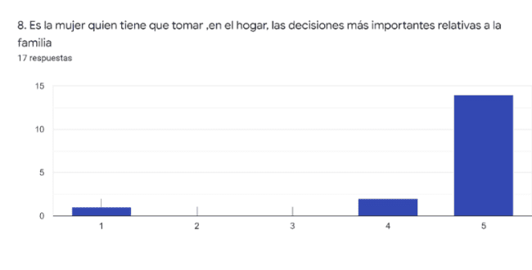
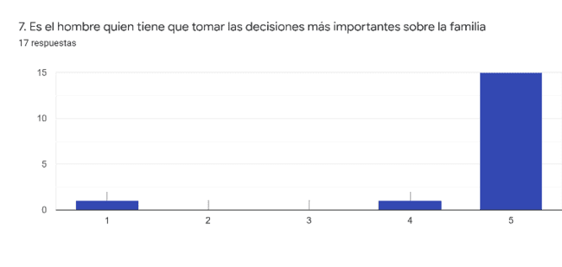
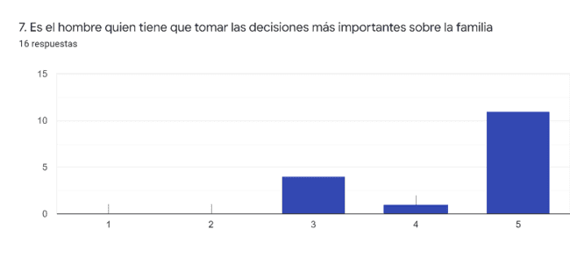
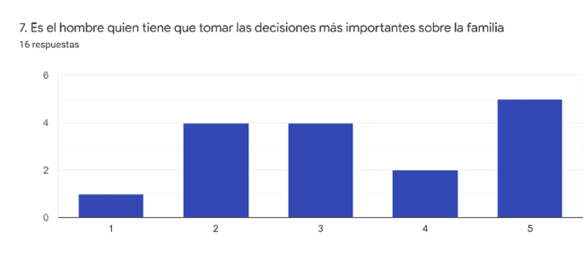

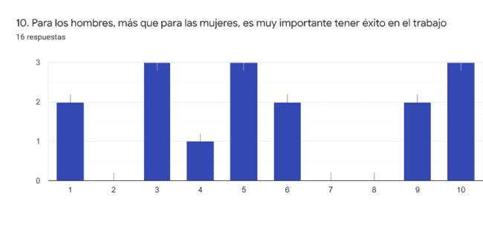
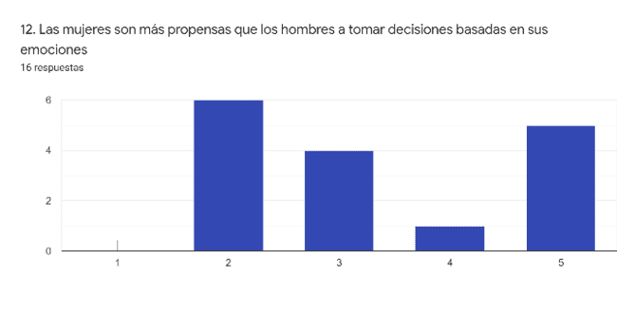
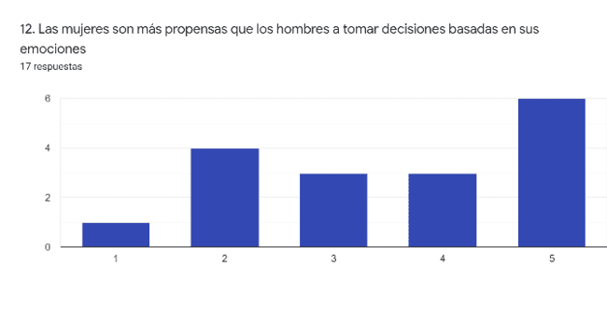
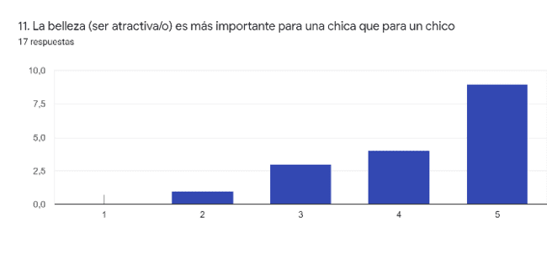
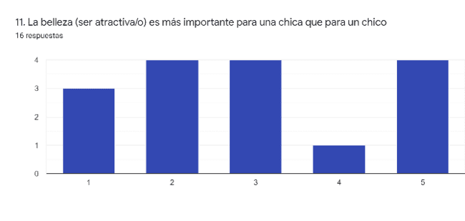
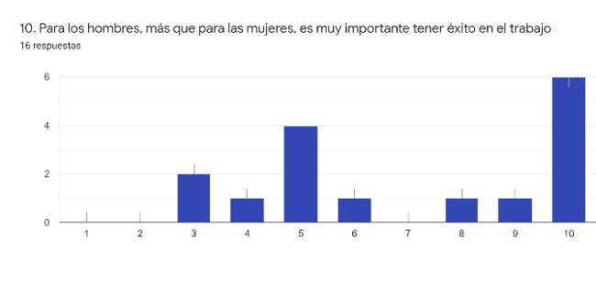
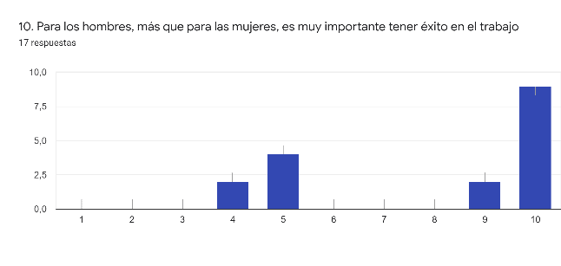
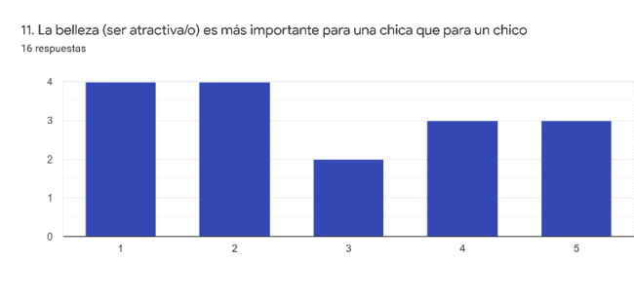
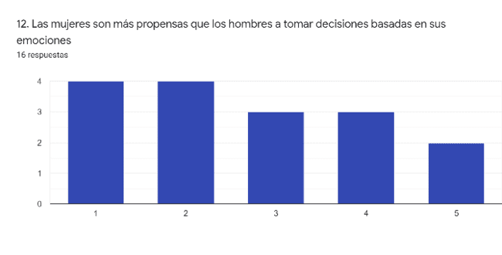

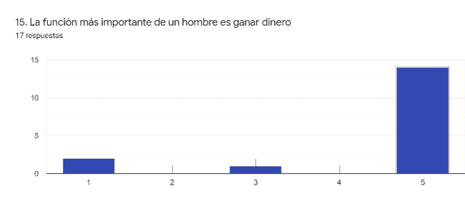

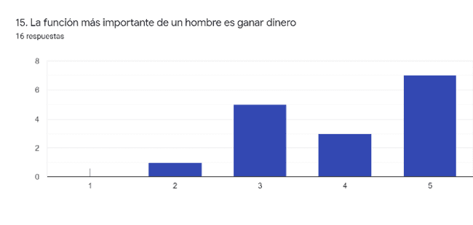
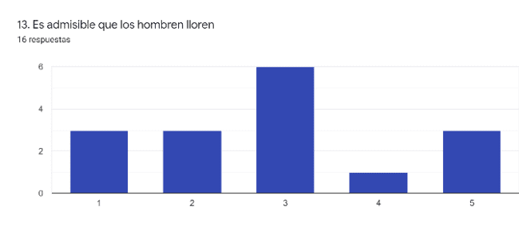

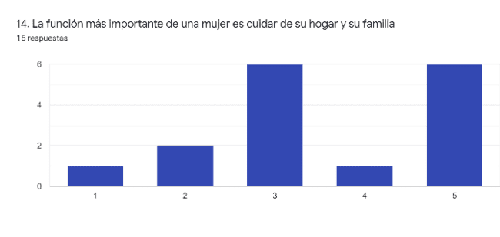

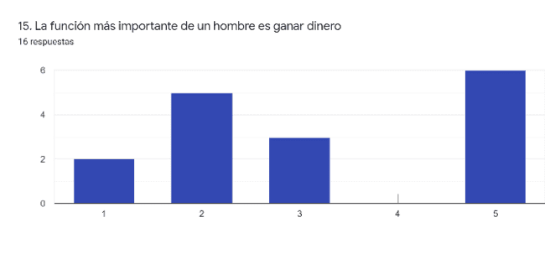
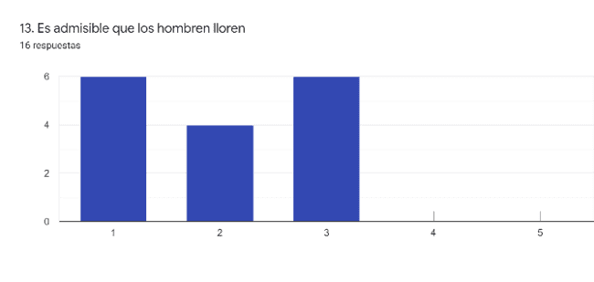
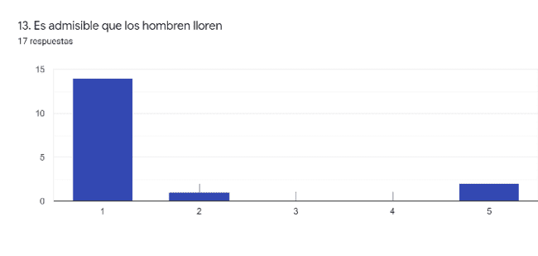
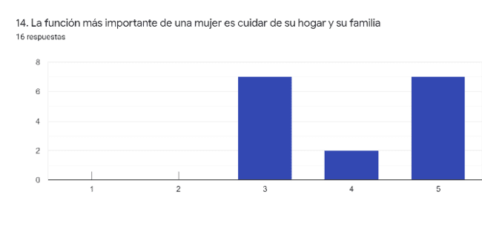
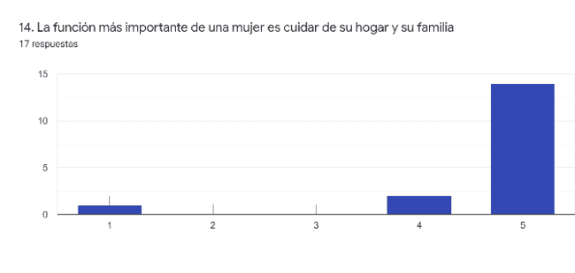
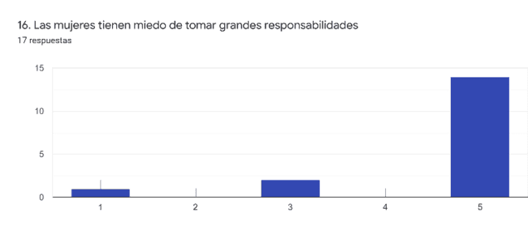
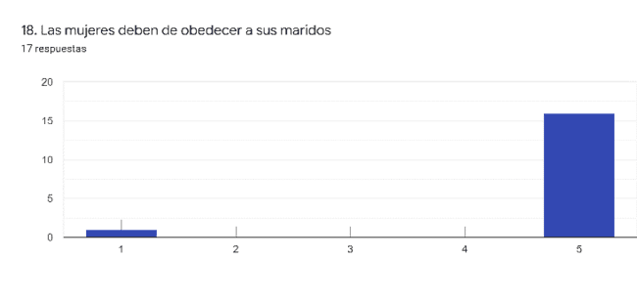
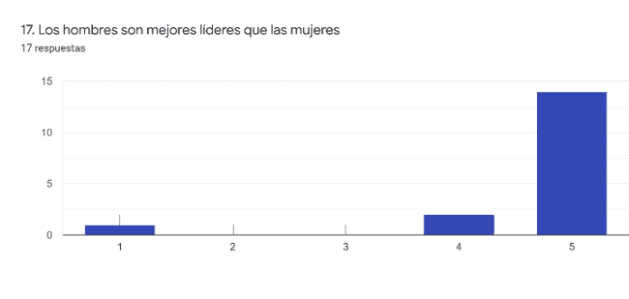
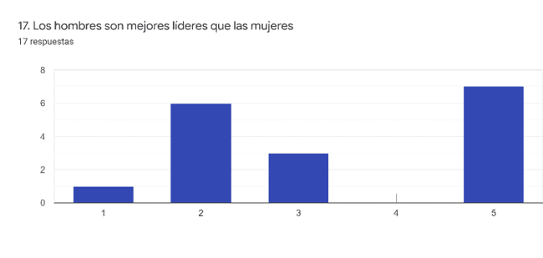
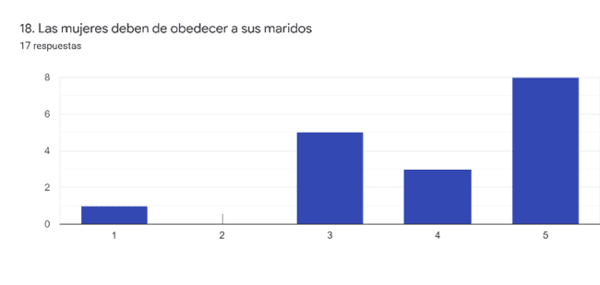
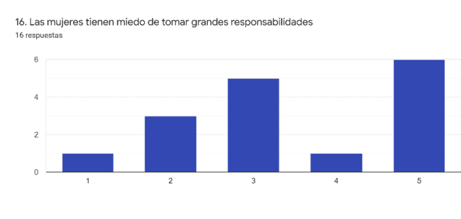
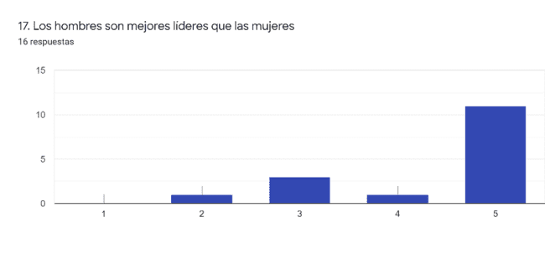
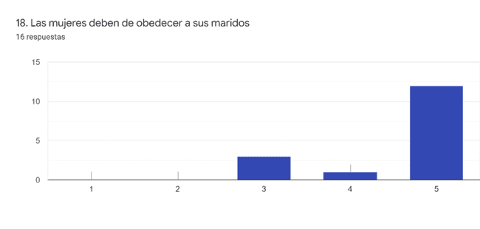
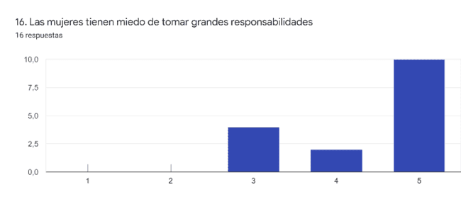

CONCLUSIONS
The results of the educators' questionnaires show us a tendency to value the students' opinion as more sexist. Although teachers show a clear rejection of sexist or gender stereotyped statements, their opinion of the approach and views of the boys shows that they consider the students to have ingrained sexist beliefs.
In terms of comparison with the results obtained from the students, against what teachers thought they could believe or answer, students gave more importance to criteria such as loyalty, respect, mutual comprehension, and feeling understood. All these criteria are far from sexism, and even if the average doesn’t show a clear positioning in favor of feminist statements, they were neither as sexist as teachers thought they could be.

Graphics obtained from educators’ results (Degree of agreement with the statements being 1 Totally Agree and 5 Totally Disagree; perceived response from students)

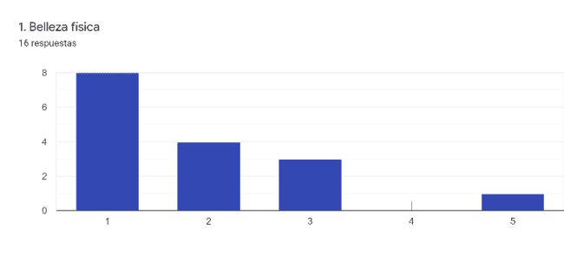
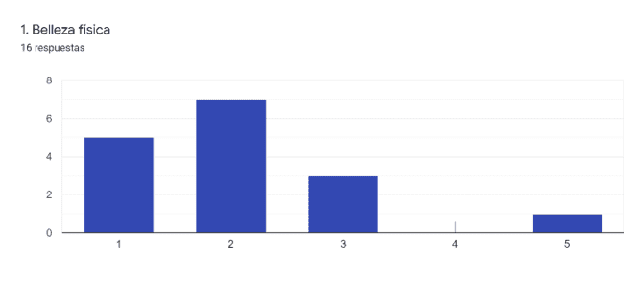
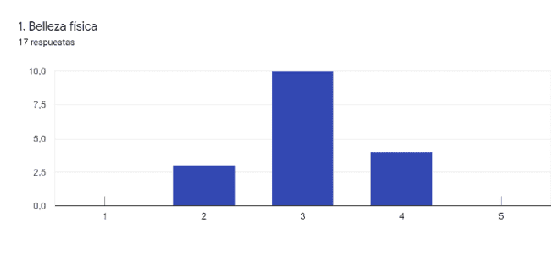
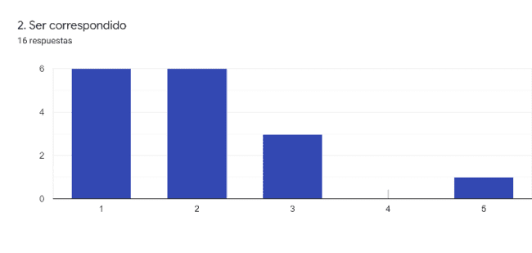
EDUCATORS FEMALES STUDENTS MALE STUDENTS
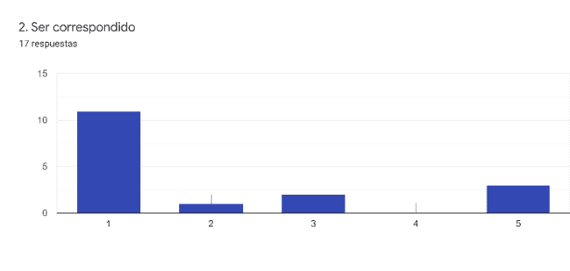

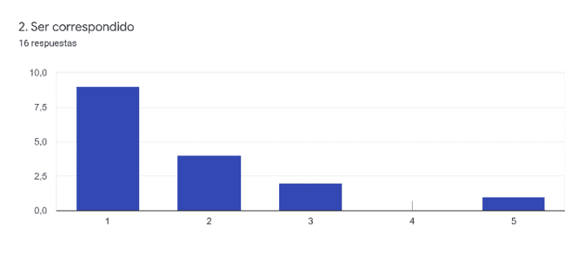

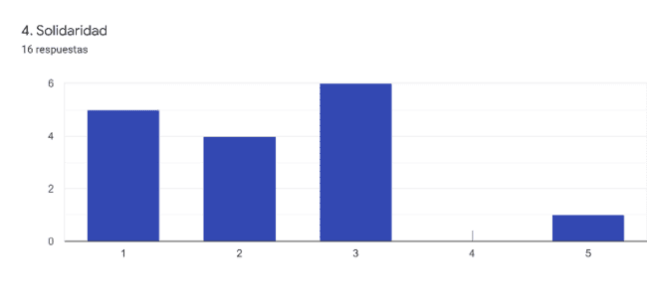
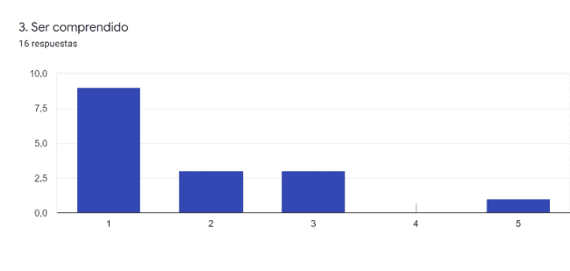
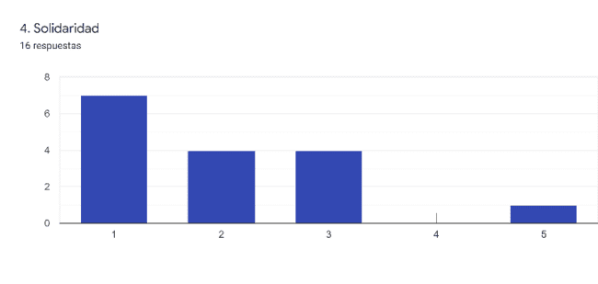
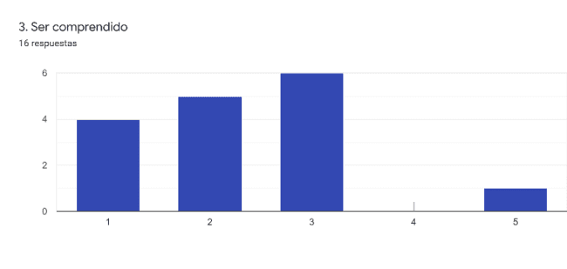
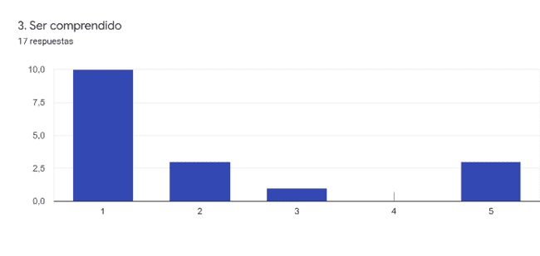
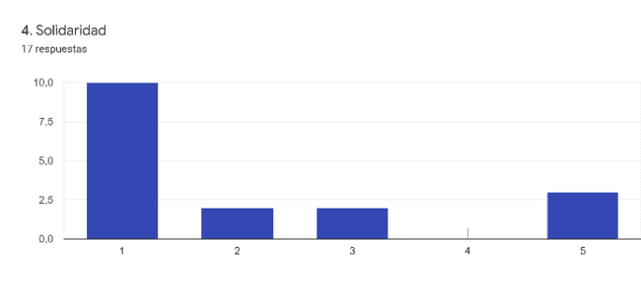

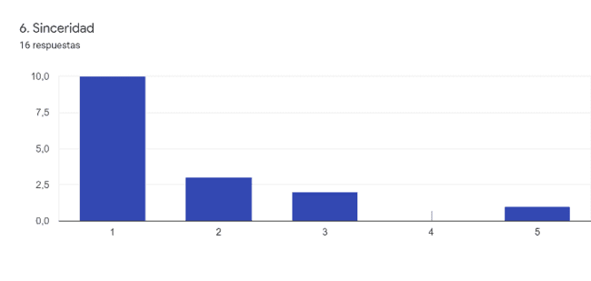
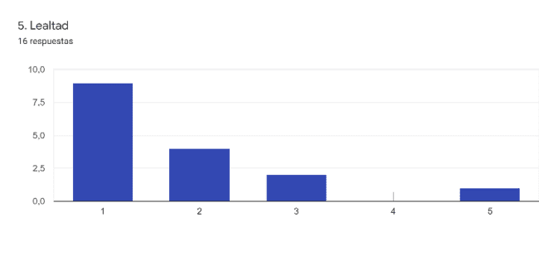
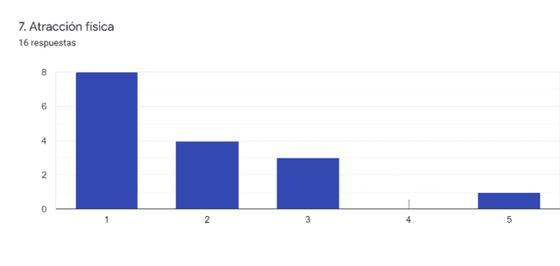
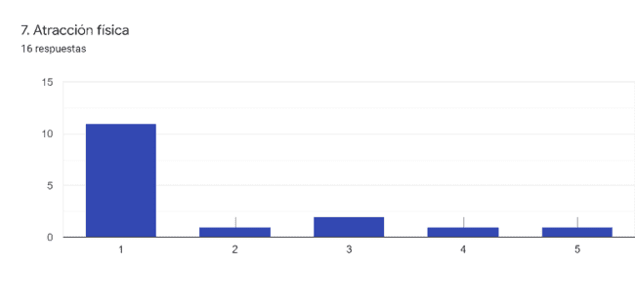
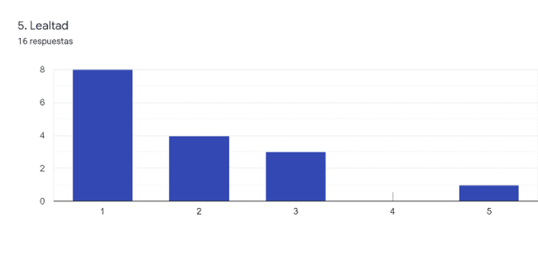
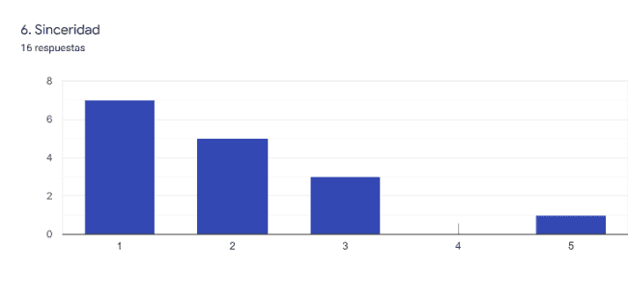
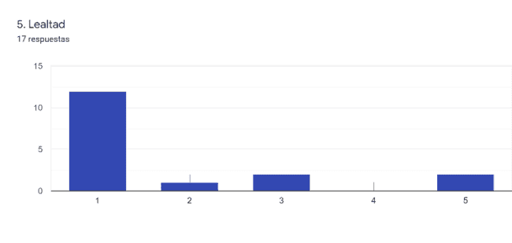
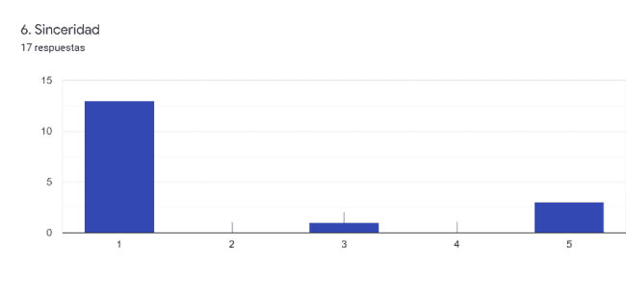
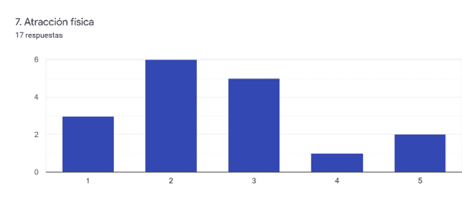

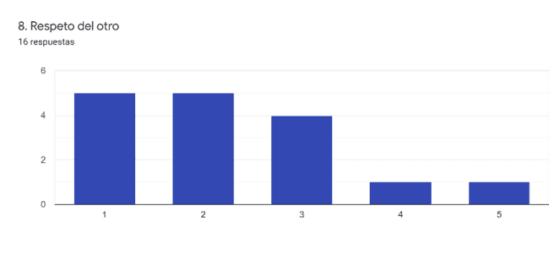
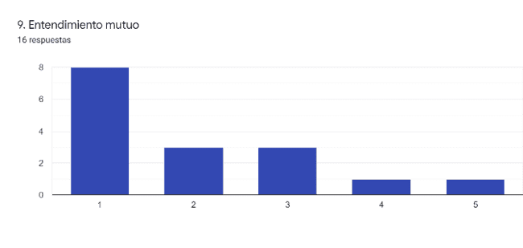
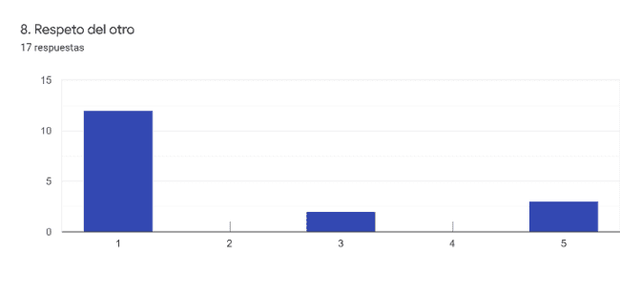

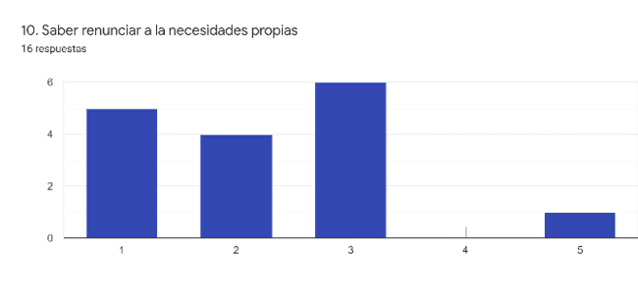

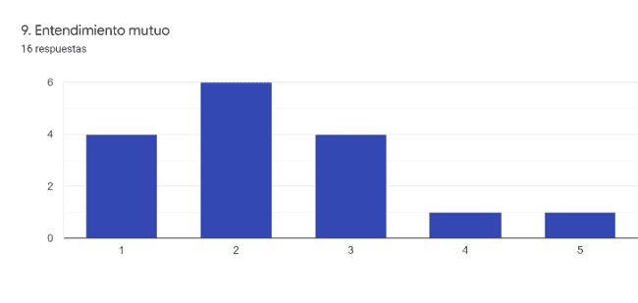
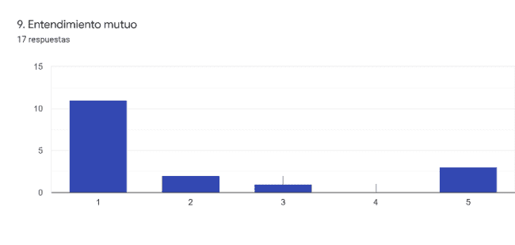
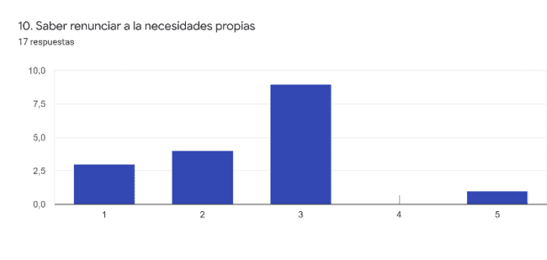
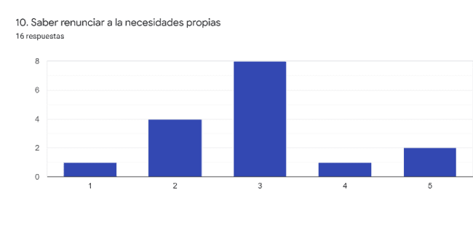
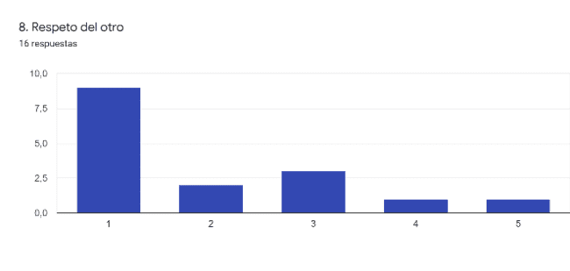
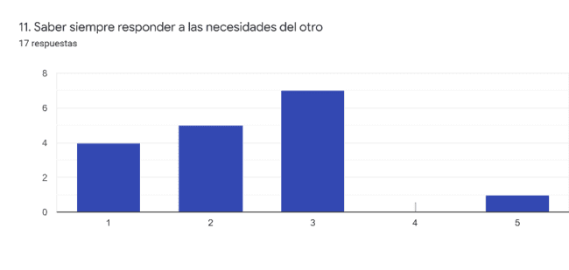
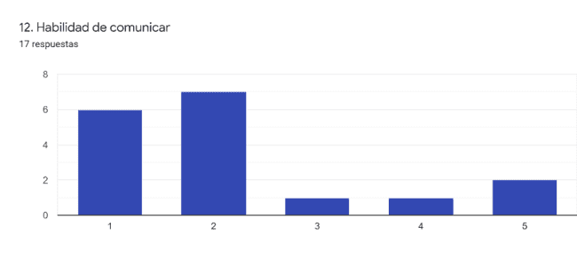
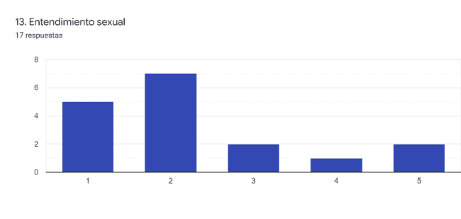
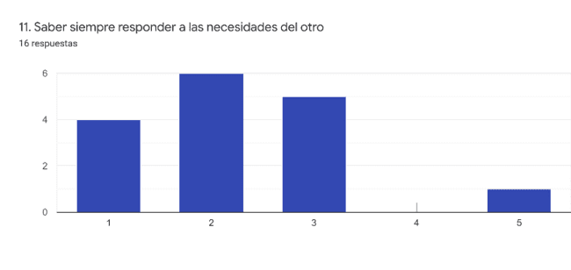
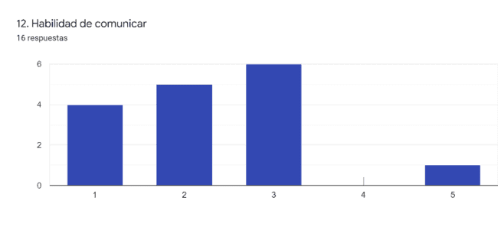
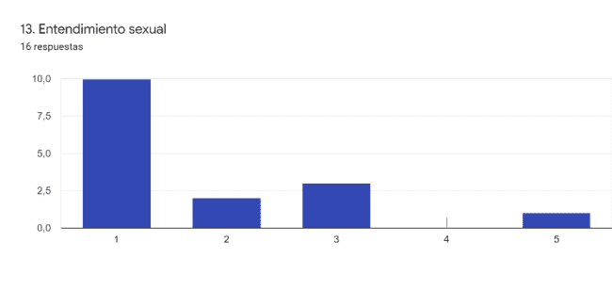
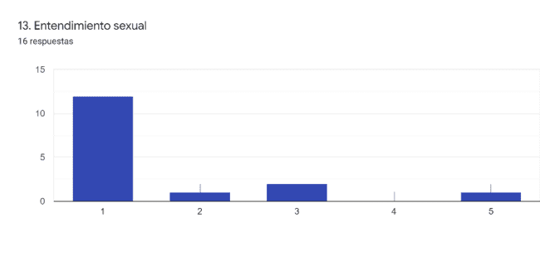
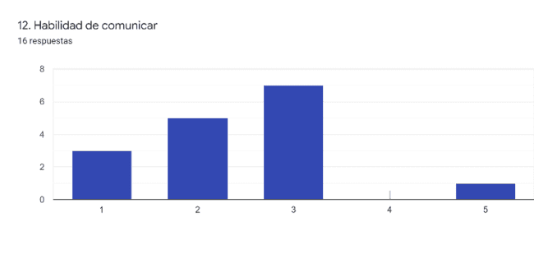
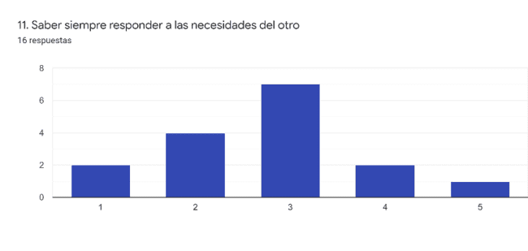

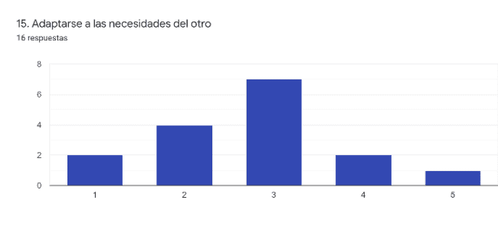
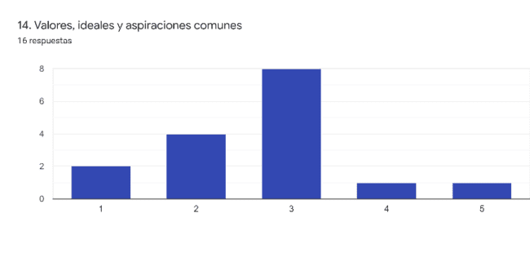
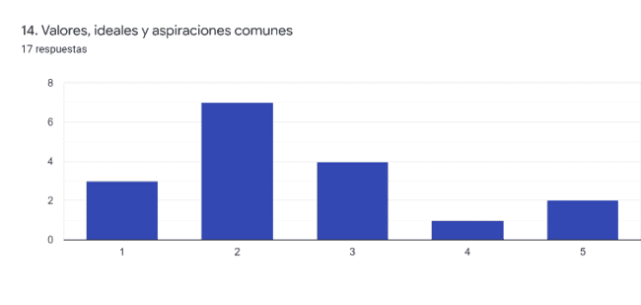
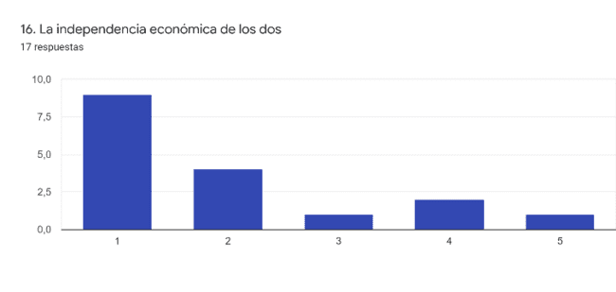
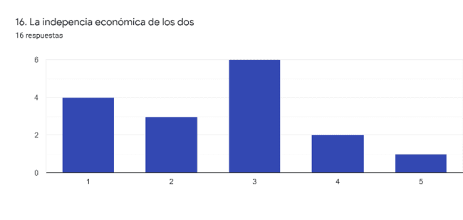

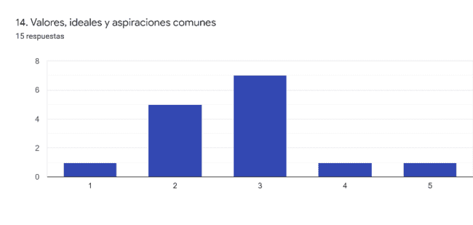

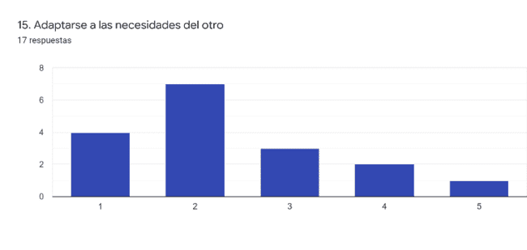
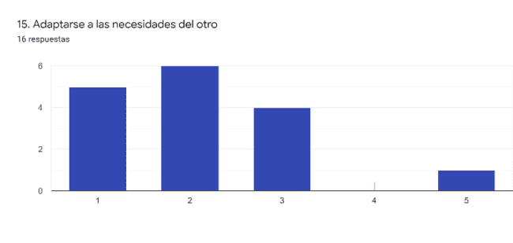
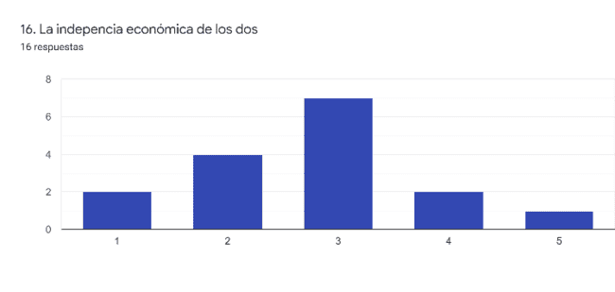
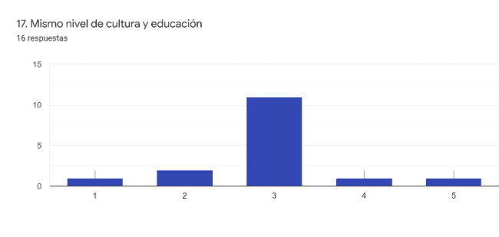
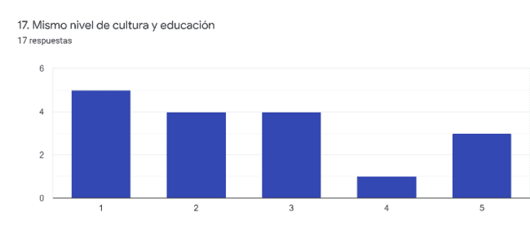

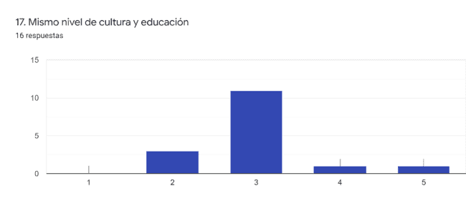
CONCLUSIONS

The results observed in relation to the question about values in the couple indicate in a very slight way that teachers consider that their students (more accentuated in the group of boys) consider physical aspects, or of sexuality, as very relevant in their couples. This could be associated with teachers considering their students to be superficial, however it could also be considered that they have this consideration due to the age of the boys (post-adolescence) and that it does not consist of a gender trait but of age. Similarly, there is a significant difference in these values when they talk about girls and when they talk about boys.
As regards other values not associated with sexuality or physicality, it should be noted that teachers consider the presence of values such as being understood, solidarity, respect for others, mutual understanding or economic independence to be of great importance, while their perception of their students' point of view is that they do not give it as much importance. It should also be noted that teachers consider that girls value the ability to give up their own needs more highly than boys, which could be associated with underlying macho beliefs (women care, they are at the service of others).

