IO 1 - Stereotypes analysis and good practices to break them down
This output is the result of the first phase of the partnership's work. An analysis grid will be prepared (which will be shared during the first transnational meeting) through which each partner will carry out an analysis of the presence of stereotypes within formal learning contexts (schools, training organizations, etc.) informal and non-informal formal (places of aggregation of young people, working environments, associations, etc.) through the support of educators. A meeting with the preliminary educators will be carried out (see the paragraph dedicated to the implementation of the project) during which the path drawn by the project and the analysis grid will be illustrated. At the end of the analysis, the results will be shared and discussed and the recurring stereotypes identified both among young people and among the educators themselves (conscious and unconscious type). The analysis grid will be the result of the work of the psychologists who make up the resources of the partnership. It will be tested beforehand with a sample of educators and students (chosen according to common criteria defined and shared among the partners) and subsequently implemented. This tool will not be composed only of questions but also of images, film evocations, stories that will invite the interviewee to reflect on his own idea of ​​male and female gender. The fine tuning and administration of the analysis grid takes a long time, as well as the administration and analysis of the results. Furthermore, at the end of the analysis, the results will be presented and discussed with educators and young people. The recognition of stereotypes will be the fundamental step for their abatement (break down).
This study will lead to the identification of educational and training practices in use that feed the presence of gender stereotypes and the practices that instead combat it.
At the end of this study, the good practices that emerged during the survey will be highlighted and collected in a handbook in each language of the partner countries and in English. The handbook is the innovative element of OI: both the analysis grid and the results will be the result of an original and participated research between educators and young people. The analysis grid, at the end of the survey, will be further refined and made an autonomous product that can be used as a test in any learning context.
The expected impact of this IO is to bring out the conscious and unconscious stereotypes present in each of us that are at the basis of discriminatory attitudes, intolerance and, ultimately, violent behaviour. Furthermore, in the course of returning the results of the analysis which will take place, as indicated, through more meetings with educators and young people, a more informative part will be dedicated to the juridical figures of the working group, where knowledge will be provided on the rights of victims and men of violence (physical, sexual, economic and psychological). In this way we want to raise the level of knowledge (impact) on the subjects of civil and social rights also from the legal point of view (both among young people and among educators) which, as the experience of the partners in this area has shown, they are by no means extensive and known.
During these meetings, the representatives of the Equal Opportunities Department who gave their external support to the project will also be involved.
Lead Organization: Associazione Nazionale Telefono Rosa

What the project foresees…. | Front Activities carried out | Products/number
Questionnaire for the survey | Number of on line and “live” meeting - 3 | Numbers of questionnaire – 55
Survey among students, youngsters, | - Questionnaire d'enquête sur les stéréotypes – Étudiant.e.s  - 1 video for students | 52
Survey among educators | - Questionnaire d’enquete sur le stereotypes - Enseignant.e.s/ éducatrices, éducateurs  - Number of on line and “live” meeting – 2  - 1 video for educators | Numbers of questionnaires – 3
Survey among parents (optional) | - Questionnaire d’enquete sur le stereotypes- Parents  - Number of on line and “live” meeting | Numbers of questionnaires -0
Reports of survey | Elaboration of the results and visualization | Handbook – 1 in French and 1 English

Handbook template (draft proposal)

- Methodology of the survey and solutions adopted (facing pandemic period)

Starting from January, after translating the questionnaires into French, we singled out 3 organizations to collaborate with:
- Collège Don Bosco,
- Institut Technique René Cartigny
- CEMEA Association.

We organized a meeting with the managers of these institutes in order to get to know them better during which we walked them through the project, the methodology and the expected results. During these meetings, we had an opportunity to dive deeper into the practices currently in use and the tools available to us to combat stereotypes in the context of schools. Throughout the whole duration of this phase, we were constantly involved in the analysis and collection of ’good practices'.
The managers put us in touch with some of the most active and most committed professors on the subject to plan the activity with them. We were therefore able to organize a first meeting with them, during which the project, the methodology and the expected results were explained. Our planning stalled almost immediately due to the first lockdown. The activity at this point was flanked by the increasing uncertainty of the teaching staff regarding the evolution and political decisions that would have been taken to respond to the current situation. The schools remained closed until May and we decided to resume contact with the professors in September to reschedule the activity. Some professors have suggested we create videos to tackle the issues associated with direct meetings. To avoid delays, however, we started preparing 2 videos (1 for teachers and 1 for students). In September the schools reopened, alternating moments in presence with online lessons. The associations found themselves unable to work and one of the schools preferred not to continue this activity as this situation had caused them delays in planning their teaching. We remained in contact with the Don Bosco School with which we organized a more extensive meeting involving all the teachers of the "experimental" class. Thanks to the collaboration with the Institute d’Egalite des femmes et des hommes, we were able to combine the video with a short lesson on gender stereotypes, their link with violence and their impact on society. We then started distributing the video and, also considering the extended closure of schools from October 31st to November 15th, we only managed to get the first results back on November 20th. As for the parents, we were unable to get in touch with them even through the teachers.

- General results of survey

What emerges from a primary analysis is a higher concentration of stereotypes in girls, especially related to physical beauty and emotions.
If we refer to the stereotypes referred to man, the response of boys is never extreme, at most neutral, showing greater prudence and fewer adherences to the stereotype.
The response of girls is in most cases more extreme than that of boys (strongly agree, strongly disagree) or goes in the direction that seems to favor the stereotype
Taking a weighting on the samples and considering that girls are more present than boys in this study we can say that these results can give us an orientation, but clearly the number of data is too low to draw exhaustive conclusions.
For teachers, difficult to make statistics on 3 people but their diversity is interesting: two women, one younger and one man. The man does not always have the same answers as his two colleagues. In the prediction that the professors make of the boys' answers, we notice a somewhat stereotyped vision.
This could mean that it is important to equip them and young people of both sexes.
A fact that we should take into consideration is also linked to the fact that the answers come in a difficult moment (COVID).
Unfortunately we have not yet had the opportunity to discuss the results with our experimental class but we plan to do so as soon as the environmental situation allows.

- What kind of stereotypes comes from the survey?
Some stereotypes now seem outdated (men can cry, they must earn money), those that have emerged most are related to the physical appearance and the care role that women have always played:
- Women are better suited to raise children than men
- Beauty (being attractive) is more important
- Women are more likely than men to make decisions based on their emotions

- What level of acceptability of gender based violence from the questions?
We don’t think that the analyzed sample shows signs of strong sexism and acceptability of GBV.

- Images, screen shot and other visual material collected during the meetings (live and online).

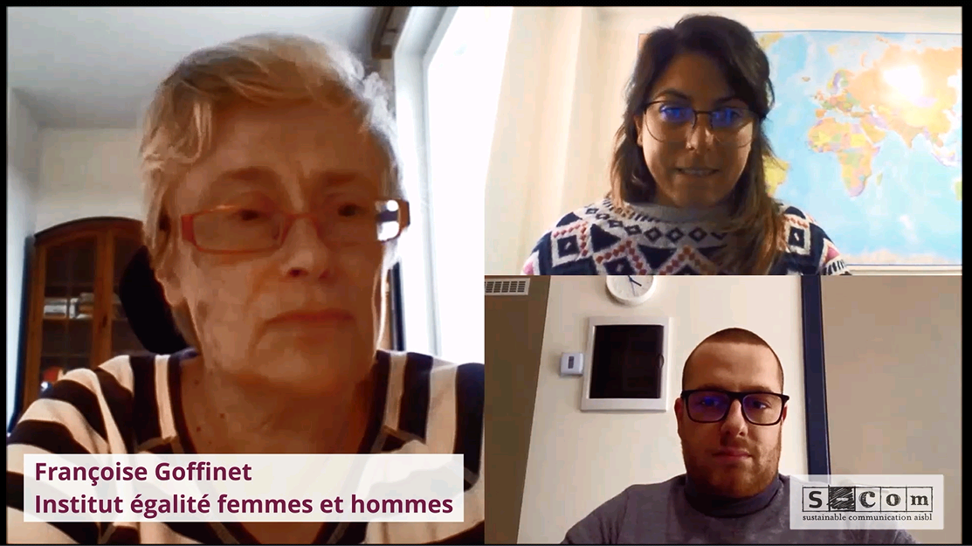

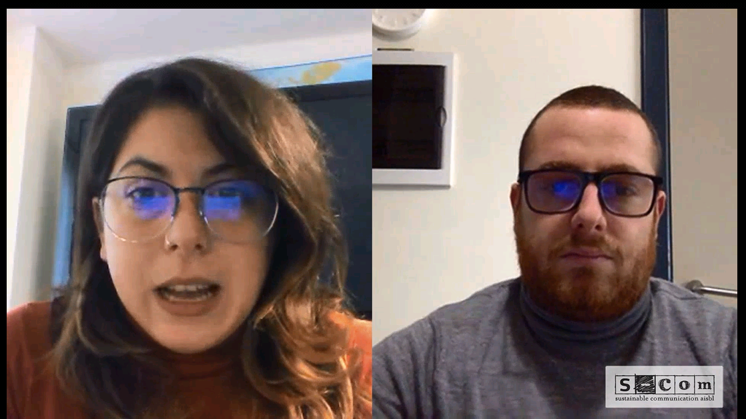
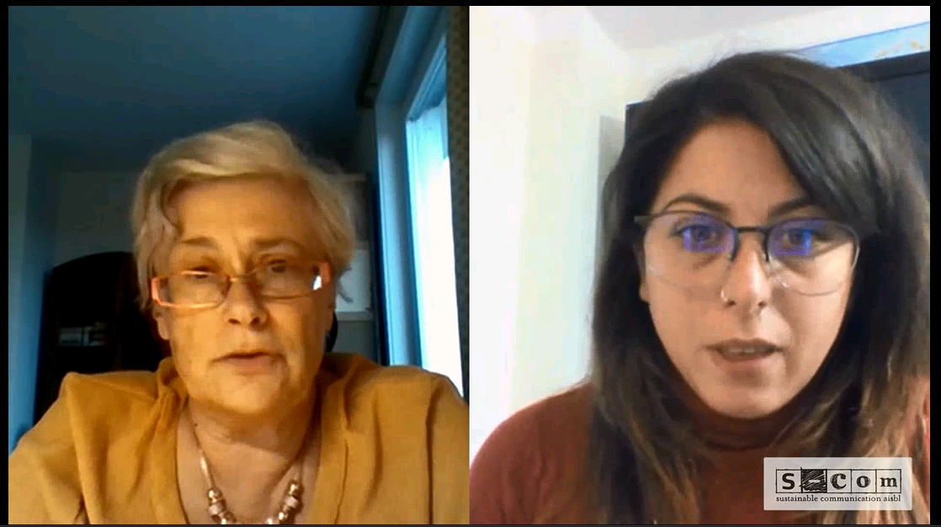

Video for students
Video for professors
Slide PPT for students
Slide PPT for professors

Other material collected
- Girls day, Boys day - Guide d'animation - This guide offers fun activities to be implemented with the students, but also explanations of concepts and references to deepen the subject of gender stereotypes in career choices.
- Indicateurs dans l'enseignement supérieur: ARES manages a system for collecting, analyzing, researching and disseminating statistical information on higher education in the Wallonia-Brussels Federation
- Les indicateurs de l'enseignement: each year, the Wallonia-Brussels Federation publishes a certain amount of statistical information which allows us to understand the evolution of teaching.
- Filles - Garçons, égaux dans l'enseignement?: compilation and highlighting of the main findings of seven studies by making useful cross-checks in order to identify what is consensus on gender stereotypes at school
- Statistiques du personnel de l'enseignement: for several years, ETNIC has published a series of figures on education in the Wallonia-Brussels Federation.
- Egalité entre les hommes et les femmes en Wallonie dans l'enseignement: proposed by IWEPS this statistical photograph deals with the positioning of women and men in education.
- Initial and continuing training module"Filles-garçons : une même école ?" (2018)
- Sexes & Manuels – Publication (2012) Educational tool aimed at promoting the equality of girls and boys, men and women, in school books.
- Moi aussi je peux le faire - Publication (2011) For teachers and students of secondary or higher education; taking stock of gender equality in scientific and technical professions and denouncing stereotypes (ULg, aSPe, in collaboration with AGERS and the Directorate of Equal Opportunities, FWB, 2011)
- Centres d’Entraînement aux Méthodes d’Éducation Active (CEMÉA) - « Pour une éducation à l’égalité des genres- Guide de survie en milieu sexiste » is a publication that aims to deconstruct the major myths used to legitimize inequalities between women and men in our society.
- Mettre au féminin GUIDE DE FÉMINISATION DES NOMS DE MÉTIER, FONCTION, GRADE OU TITRE
- Integration of content on violence against women in higher education ", in particular Recommandation des contenus de cours relatifs aux violences faites aux femmes, to be included in higher education" which may concern several of us!
- In this publication, we propose to deconstruct the processes that create and perpetuate inequalities, but also that transform them. We discuss gendered socialization at different stages of individuals' life cycles, but also according to the various places of learning: formal, non-formal and informal education
- https://popmodeles.be/
- https://media-animation.be/Sexisme-medias-et-societe.html

