IO 1 - Stereotypes analysis and good practices to break them down
Telefono Rosa Hand book

1) Introduction 2
2) Methodology of the survey and solutions adopted (facing pandemic period) 4
3) Definition of gender stereotype 4
4) Results of the survey and of the meeting with students, teachers and parents. 7
4.1. Statement results 10
Liceo Augusto 17
Liceo Terenzio Mamiani 19
5. Conclusions 22

Introduction
Telefono Rosa Association has always believed in the cultural roots of gender-based violence. For this reason, its only tools to eradicate these dangerous roots have always been training and education. The European project UP&UP allows the association to establish a methodology for a training package in the field of identification and elaboration of gender stereotypes.
The project is based on the assumption that gender-based violence has cultural roots. To demonstrate this link, a questionnaire was prepared to highlight the links between stereotypes and gender-based violence. THE QUESTIONNAIRE, during the first phase of the project, was the fundamental tool to create the necessary synergy between the pupils of the classes involved, teachers and parents.
How can culture be changed?
1) Acting on young people, so that they can acquire a critical spirit enabling them to recognise and deconstruct stereotypes.
2) Train teachers and enable them to have the necessary tools to teach and disseminate a new culture that is increasingly free from gender stereotypes.
3) Raising family awareness to make parents more aware educators.
The output of these phase of the project is the result of the first phase of the partnership's work. An analysis grid was prepared (and was shared with the partners during first transnational meeting) through which each partner carried out an analysis of the presence of stereotypes within formal and informal learning contexts, through the support of educators. A meeting with the preliminary educators was carried out during which the path drawn by the project and the analysis grid had been illustrated. At the end of the analysis, the results was shared and discussed and the recurring stereotypes identified both among young people and among the educators themselves (conscious and unconscious type). The analysis grid was the result of the work of the psychologists who make up the resources of the partnership. It was tested beforehand with a sample of educators and students (chosen according to common criteria defined and shared among the partners) and subsequently implemented. Furthermore, at the end of the analysis, the results was presented and discussed with educators, young people and parents.
The gender stereotype analysis grid had different meanings for teachers, parents and students.
For educators and teachers:
1) A didactic support
2) A tool for recognising and combating gender-based violence.
For students/youngers:
3) An increase in their awareness of sexist stereotypes that condition and negatively influence their desires and life choices.
4) Developing their critical tools that enable them to recognise and counter attitudes and behaviours that lay the foundations for violence and prevarication.
5) Ability to manage and understand unbalanced relationships that can develop in friendship and love relationships in all contexts of social and family life, in real or virtual places.
For Parents:
1) A way of reflecting on their own stereotypes and opinions about their children.
2) An opportunity for parents and teachers to reflect on topics that are not often addressed at school.

What the project foresees…. | Front Activities carried out | Products/number
Questionnaire for the survey | Number of on line and “live” meeting | Numbers of questionnaire
Students
Liceo Augusto | 2 meetings  1 in presence  1 on line | Numbers of questionnaire:  20
Liceo Terenzio Mamiani | 2 meetings  1 in presence  1 on line | Number of questionnaire:  25
Educators/Teachers
Liceo Augusto | 1 meeting on line | Numbers of questionnaires:  8
Liceo Terenzio Mamiani | 1 meeting on line | Numbers of questionnaires:  6
Parents
Liceo Augusto | 1 meeting on line | Numbers of questionnaires:  26
Liceo Terenzio Mamiani | 1 meeting on line | Numbers of questionnaires:  31

Methodology of the survey and solutions adopted (facing pandemic period)

In order to know how this gender stereotypes are widespread among young people, teachers and parents, is possible to use a grid of analysis that this project tested during 2019 -2020 years that have two objectives:
- Acknowledging the gender stereotype among youngers/students, parents and teachers
- Discover which are the opinions that parents and trainers have to the gender stereotype among youngers.
To do that the questionnaires dedicate to parents and teacher contain a set of questions aims to investigate which is, for each questions and statement proposed, the supposed answer of youngers. This tools that we have called “mirror questions”.
Questionnaire was defined departing from the issue already adopted at European and Italian level to investigate the gender stereotype among population. In particular, the statement reported on the questionnaire are directly connected to the Eurobarometer survey on Gender Equality and to the Italian Survey on gender stereotype and social image of gender violence. The purpose of the methodology was aimed to collect date at local level and to compare the results among two schools with the results obtained at national and international level. So before to give the results among the Italian schools this report will describe the framework between the analysis was built.

Definition of gender stereotype
Stereotypes are generalised images about people within a society. A gender stereotype is a preconceived idea where women and men are assigned characteristics and roles determined and limited by their gender.
Stereotypes about gender often take one of two forms. One assumes all members of a category (such as a profession) share a gender, for example the assumption that all company directors are men and all secretaries are women. The other is assuming that all members of a gender share a characteristic, for example believing that all women love to shop or that ‘boys don’t cry’.
These stereotypes hurt people of all genders by placing expectations on what people should be.
“Traditional gender roles and stereotypes continue to have a strong influence on the division of roles between women and men in the home, in the workplace and in society at large, with women depicted as running the house and caring for children while men are depicted as wage-earners and protectors"
Even now when more women than ever before are hired to lead organisations and more men use their right to parental leave the effects of gender stereotyping cannot be underestimated. One still observes the persistence of stereotypical gender perceptions across different generations, countries of the European Union and fields of life. It is in most everyday realities that gender matters – in education, work, family and relationships, health, leisure, determination of identity, society life. Despite the changing realities gender stereotypes remain deeply ingrained, still very vivid and consistent.
In many different ways gender stereotypes have far-reaching societal influence and are detrimental to the lives of both, women and men. They limit people’s freedom and choices. They lead to discrimination. They cause unnecessary suffering. Because of the insidious effects gender stereotypes need to be addressed on different levels and by different actors.
Violence against women, and domestic violence especially, are varied and complex phenomena, and knowledge of them is essential to the development of policies to fight violence against women and the establishment of a system to monitor it. These phenomena are rooted in gender culture, and therefore it is necessary to research stereotyped models of women’s and men’s roles as well as the social image of violence. The spread of gender role stereotypes, on the one hand, and the attitudes towards violent behaviour, on the other, are in fact the keys to understand the cultural context in which violent relationships find their genesis and justification. Knowing about them is essential to a better understanding of the causes of violence and monitoring them over time in order to evaluate, at least partially, how policies involving violence prevention impact the population in terms of cultural change.
3.1 European framework
At European level there is an important survey that gives us some data to reflect. Based on Eurobarometer’s survey, Almost nine in ten respondents believe that it is acceptable for men to cry, with the majority (54%) totally agreeing to this statement. One in ten respondents think it is unacceptable for men to cry (10%). Women are much more likely to totally agree than men (60% vs. 49%), although overall agreement levels are close (91% women, 86% men). Almost seven in ten respondents think women are more likely than men to make decisions based on their emotions (69%), with 25% in total agreement with the statement. There is little difference between men and women (67% vs. 71%). More than four in ten (44%) believe the most important role of a woman is to take care of her home and family, with 17% in total agreement. The ajority, however, disagree (54%). There is no notable difference between the opinions of men and women. Only a minority (43%) believe the most important role of a man is to earn money, with 16% totally agreeing to this statement. The majority (55%) disagree with the statement. Men are, however, more likely to think in such a way than women (47% vs. 41%).
3.2 National data
Also in Italy, ISTAT carried out the first survey on gender Stereotype on 2019. This survey reports also the social image of gender violence and the results are very impressive. The most common stereotypes about gender roles are: ‘for the man, more than for the woman, it is very important to be successful at work’ (32.5%), ‘men are less suited to do housework’ (31.5%), ‘it is up to the man to provide for the family’s financial needs’ (27.9%). The statement with the lowest level of agreement is ‘it is up to the man to take the most important decisions about the family’ (8.8%).
- Without particular differences between men and women, 58.8% of the population (aged 18-74 years) have these stereotypes, which are more widespread as age increases (65.7% of those aged 60 to 74 and 45.3% of people aged 18 to 29) and among the less educated.
- The stereotypes are more frequent in Southern Italy (67.8%), especially in Campania (71.6%) and in Sicily, and less often in the North-east (52.6%), with the fewest in Friuli Venezia Giulia (49.2%).
- On the subject of intimate partner violence, 7.4% of people think it is always or under certain circumstances acceptable that ‘a young man slaps his girlfriend because she flirted with another man’, and 6.2% think that in a relationship a slap might occasionally occur. Regarding control, however, more than double that number (17.7%) think it is always or under certain circumstances acceptable that a man habitually control his wife’s/girlfriend’s cell phone and/or activities on social media.
- Sardinia (15.2%) and Aosta Valley (17.4%) have the lowest levels of tolerance for violence; Abruzzo (38.1%) and Campania (35%) have the highest. But the opinions of men and women differ by region.
- To the question about why some men are violent with their girlfriends/wives, 77.7% of those interviewed answered because women are considered as property (84.9% of women and 70.4% of men), 75.5% because they abuse drugs or alcohol, and another 75% because of men’s need to feel stronger than their girlfriends/wives. The difficulty some men have in managing their anger is indicated by 70.6%, especially by women with about 8 percentage points more than men.
- Witnessing or experiencing violence in the family as a child is considered a cause of violence by 63.7% of the population, 62.6% believe that some men are violent because they cannot stand women’s empowerment, and the association between violence and religious reasons is high but less common (33.8%).
- Regarding a woman who has suffered violence from her boyfriend/husband, 64.5% of the population would recommend reporting it to the police and 33.2% would recommend leaving the partner. Out of the population, 20.4% would direct the woman to anti-violence centres (25.6% of women versus 15.0% of men) and 18.2% would advise her to use other services or professionals (counselling public services, psychologists, lawyers, etc.). Only 2.0% would suggest calling the dedicated national helpline 1522.
- The prejudice persists that assigns responsibility to the woman who suffers sexual violence. A full 39.3% of the population believes that a woman is able to avoid having sexual intercourse if she really doesn’t want to. The percentage of those who think that women can provoke sexual violence by how they dress is also high (23.9%). Also, 15.1% hold the opinion that a woman who suffers sexual violence when affected by alcohol or drugs is at least partially responsible.
- 10.3% of the population, often accusations of sexual violence are false (more men, 12.7%, than women, 7.9%); for 7.2%, ‘faced with a sexual proposition, women often say no but in reality mean yes’, and for 6.2%, serious women do not get raped. Only 1.9% think that it is not violence if a man forces his wife/girlfriend to have sex against her will.
The scenario that emerges from reading the results of the module on stereotypes about gender roles and sexual violence, including opinions on the acceptability of intimate partner violence and its possible causes, shows five categories: two are individuals with the most stereotyped convictions (36.3%), two have less stereotyped beliefs (62%) and one group shows no interest for the topic (1.8%).

Results of the survey and of the meeting with students, teachers and parents.
First phase of the project was dedicate to work in synergy with the students of the schools involved in the project, and later with teachers and parents. Precisely in line with the conviction that culture can be changed only by acting on young people, on the training of teachers and on the awareness of families to change the cultural roots of gender violence.
The high school institutions that have joined the UP&UP project proposed by the Telefono Rosa of Rome were: LICEO AUGUSTO and LICEO TERENZIO MAMIANI.
The first meeting with both schools was done in presence, just before the beginning of the lockdown in Italy; this allowed us to get to know the students and enter into direct contact with them. The first objective of the meeting was to identify with them the gender stereotypes, urging students to discover the "invisible stereotypes" that are part of our imagination and that lead us unconsciously to the cages of social roles from which it is very difficult to get out because they are not perceived as such.
The results of the survey are reported as follow.

Fig.1 – Students by gender and age

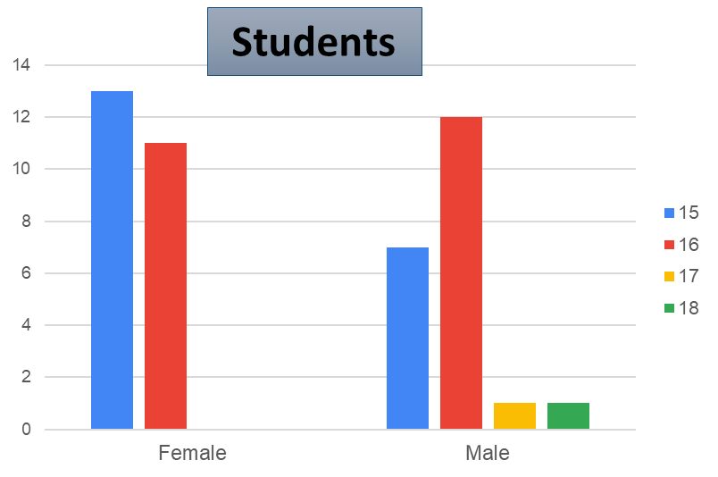
The group of students involved in the survey are between the ages of 15 and 16 years old. Only two guys are more old.
Males are more present among 16 year olds while females are present among 15 year olds.

Among teachers the prevalence of female is evident, as the Figure 2 shows.

Fig. 2 – Teacher by gender and age
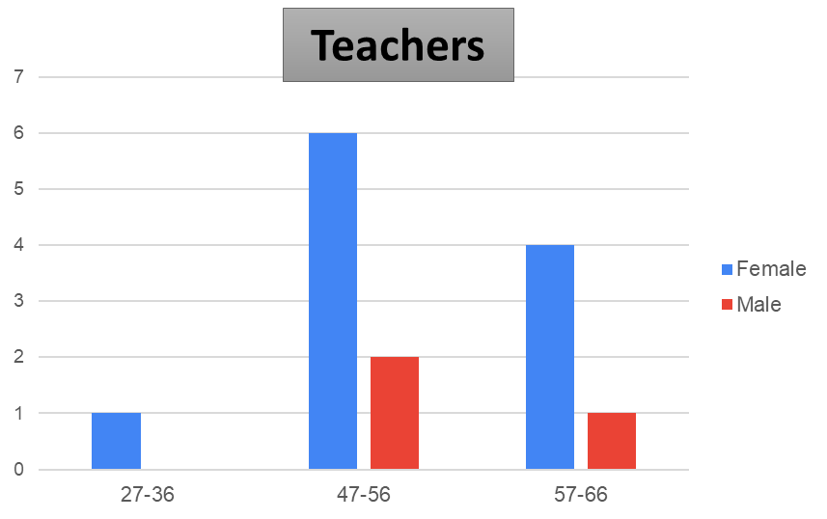
The average age of Italian teacher is about 49 years old and, as the figure shows teachers respondent of the questionnaire are in line with this average, as well as the distribution of the gender, that is, not surprisingly, in prevalence female.

Fig.3 – Parents by gender and age
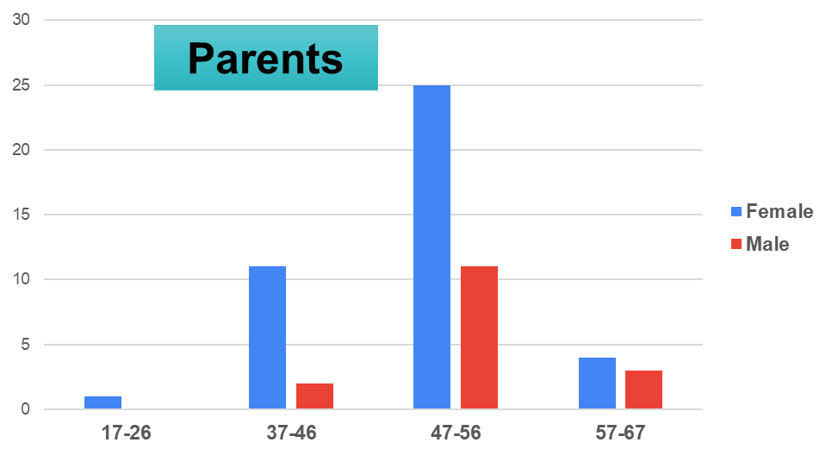
Parents’ profile is quite similar to the teachers’ one. Respondents of the questionnaire are in majority women and the distribution per age highlights a majority of people between 47 and 56 years of age.

4.1. Statement results

The first part of the questionnaire was dedicated to Indicate the degree of agreement or disagreement with certain statements that reported a gender stereotype.

Students’ answer

Fig. 4 – What is your agreement or disagreement with the following statement?
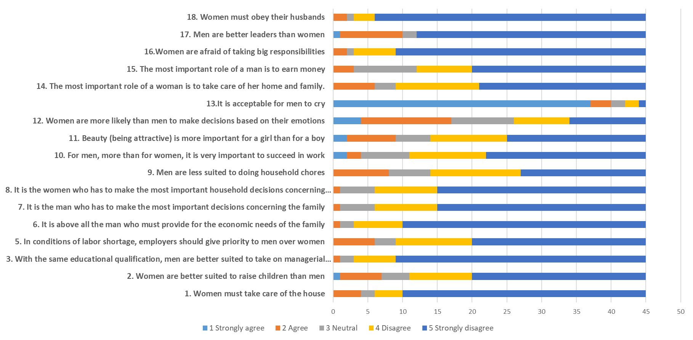
As the data shows there are still most of the young people that are agree with some typical gender stereotype as “men are a better leaders than woman” (10%) and almost 15,5% are agree with the statement “women are more likely than men to make decisions based on their emotions), as well as a relevant percentage is agree with the statement “Women are afraid of taking big responsibilities” (almost 15%). And the most impressive result that is also the females student are agree on that. Detailed results for each schools and gender is possible to visit the website section dedicate to the surveys.

Teacher’s answer
Fig.5 – What is your agreement or disagreement with the following statement?
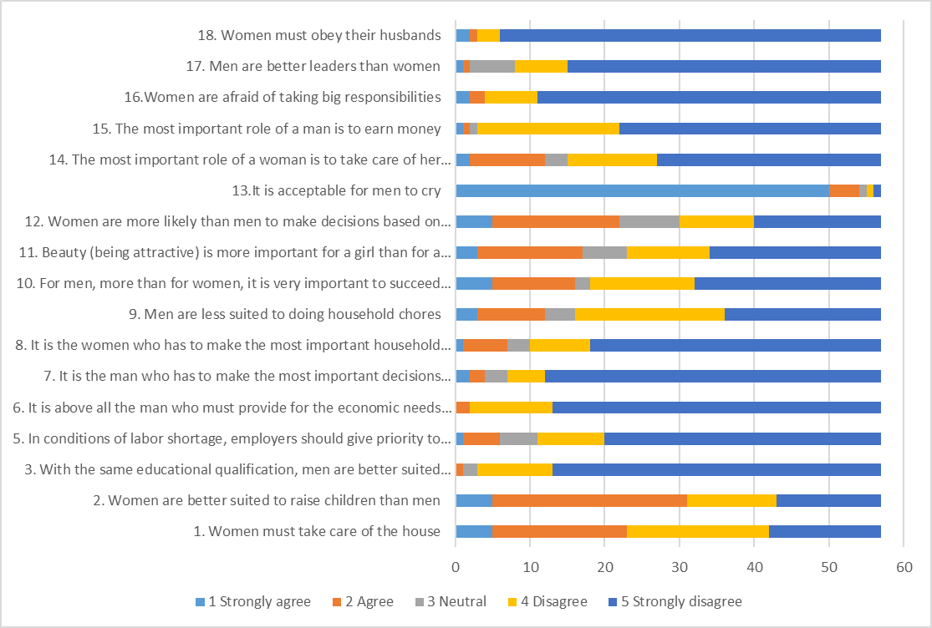

As the figure shows teacher shows a higher level of gender stereotype then the student, especially in specific statement as “women must take care of the house” (more than 20%) and “women are better suited to raise children than men” (30%). Likewise, students lots of teacher think that “women are more likely than men to make a decision based on the emotions” (22%) and the most important role of a woman is to take care her home and family” (more than 10%).
In the statement "Women have to take care of the home" the percentage of female teachers who answered in the affirmative was higher than that of female students. In the answers in general, especially considering the answers to the mirror questions, the embedding of the stereotype imagined by the teachers in the answers of the pupils often does not coincide. On the other hand, there is a greater entrenchment of prejudices in the teachers than in the students. This was confirmed by the teachers: in this questionnaire the pupils proved to be ahead of us, much more in line with the true reality. This discrepancy shows that there is a distance between us and them. It means that we did not enter into an empathetic relationship with them. We have maintained an institutional role. This result shows that these stereotypes are much more present in an adult age group, so we need to change our mind".
The meeting with the teachers and their reflections on the topics dealt with in the questionnaire highlights:
1) A wide and deep reflection on gender prejudices and stereotypes
2) The analysis of the answers and the debate foreseen at the return of the questionnaires increases the teachers' awareness on the specific theme of respect for diversity with particular reference to gender difference.
3) To verify which stereotypes still exist and their link with gender-based violence.
4) The teachers' point of view on gender-based violence.
5) Comparison with the mirroring questions and the answers given by the students (website section dedicate to the surveys). The result expressed a certain conformity with the class' answers concerning gender-based violence. With respect to the stereotypes related to the way men and women are seen, the typical looks related to the roles attributed to the female with the function linked to motherhood and to the male with the dimension of power appeared. These stereotypes are more consolidated in the teachers' answers than in those of the pupils.
6) Demonstration from the results of the answers of the existence of a greater rooting of prejudices in the teachers than in the male and female students.

Parent’s answer
Fig.6 - What is your agreement or disagreement with the following statement?
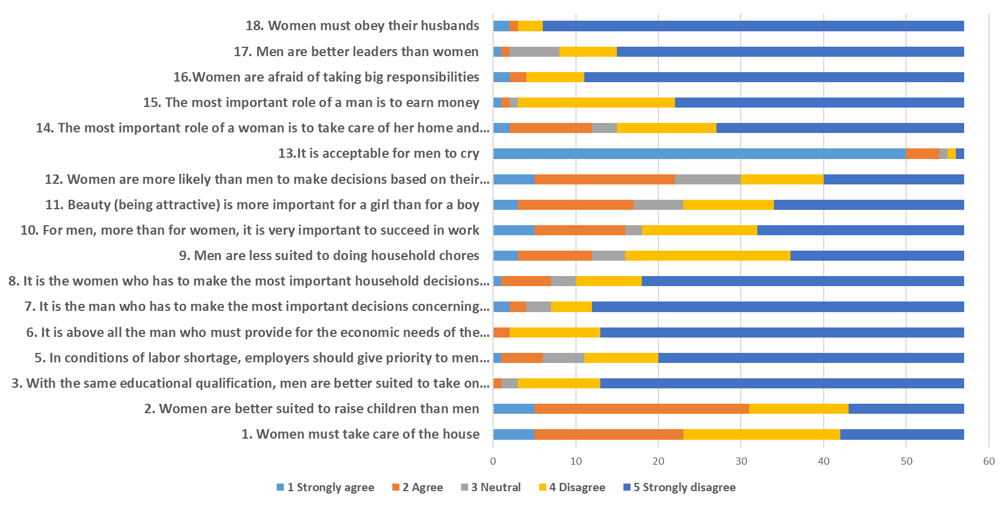

The gender stereotype had also recorded among parents that participated to the survey, in a measure surprisingly wider than theirs guys. Figure 6 clearly shows how the same stereotype already observed among teacher are stronger eradicate among parents, as well as “Women are more likely than man to make decisions based on their emotions” (almost 20% are agree with this statement) or “women are better suited to raise children than men” (more of 30% are strongly agree or agree with this stereotype).
In the case of parents, too, the administration of the questionnaire was an opportunity to initiate reflection and debate on the answers given and made it possible to broaden the view of gender stereotypes.
A particularly interesting moment was when the results of the mirroring questions were shown, which made us reflect on the difference between the parents' thoughts and the children's actual thoughts, with particular attention to the evidence of prejudice in the answers, especially in the evaluation of the answers of the male children.
The importance of this survey and the subsequent debate is confirmed by the parents' reflections. One of the mothers states: "I think it is very important to talk and sow the seeds in our children's minds about these issues. As a mother of a male child, I am particularly attentive because I believe that future generations will reap what we sow today with these males that are growing up. From the answers I realise that we underestimate our children. Especially the males. A father said, "I am impressed by the responses of the boys, inexplicably compared to some of the stereotypes that go around, our boys are ahead of us. We are children of our time and our culture, we must try to be more advanced, to be close to them with respect to these attitudes. Furthermore, for me the word 'example' is fundamental, and it is important for fathers, for males, to take the field; as long as women talk about violence against women and males do not assume the social responsibility of actively rejecting this type of violence, the results will never come.
In both schools the debate with the pupils was very important not only to bring out the stereotypes present in the class but also to touch the reactions of the people to the answers given. The responses of the students showed how much discomfort and annoyance an attitude contained in an answer can give. Observing the reciprocal reactions, becoming aware of a stereotype has raised the skills of young people thanks to a path that has made them active and interactive. These activities have stimulated reflection to increase awareness of the value of difference. This reflection helps to increase respect for others and raises civic consciousness by acting on the removal of prejudices that are the basis of intolerance and hatred.
The first line of action of the project was:
-the analysis and deconstruction of gender stereotypes with students
-detection of internalized gender stereotypes, analyzing cultural and family conditioning that affect life trajectories and choices based on one's biological sex.
In schools, discussions with pupils are very important not only to bring out stereotypes in the classroom but also to:
- touching the mutual reactions of girls and boys to the answers given. In this phase, the pupils' reactions show how much discomfort and annoyance an attitude contained in an answer can give. The pupils can directly assess the emotional weight of their statements.
- noting each other's reactions, becoming aware of a stereotype enables the young people to raise their level of competence as a result of a process in which they act actively and interactively.
This type of activity stimulates reflection and raises awareness of the value of difference. Knowledge increases respect for others and raises civic awareness by breaking down the prejudices that underlie intolerance and hatred.
Detecting stereotypes is therefore just a "pretext" for talking about them, it allows us to observe the cultural and family conditioning that affects life trajectories and choices based on one's biological sex. Lastly, joint reflection made it possible to analyse the link between sexist stereotypes and gender-based violence.
More in depth, in each school the discussion among students addressed different and specific questions that is relevant to describe.
The methodology adopted that allows to compare youngers’ opinions, teachers’ and parents’ opinions; mirror questions made it possible to understand what teachers and parents think of the stereotype of youngers, often revealing how much these opinions are wrong. The following figures gives an example of this difference and for more data are available on dedicate area of our website.
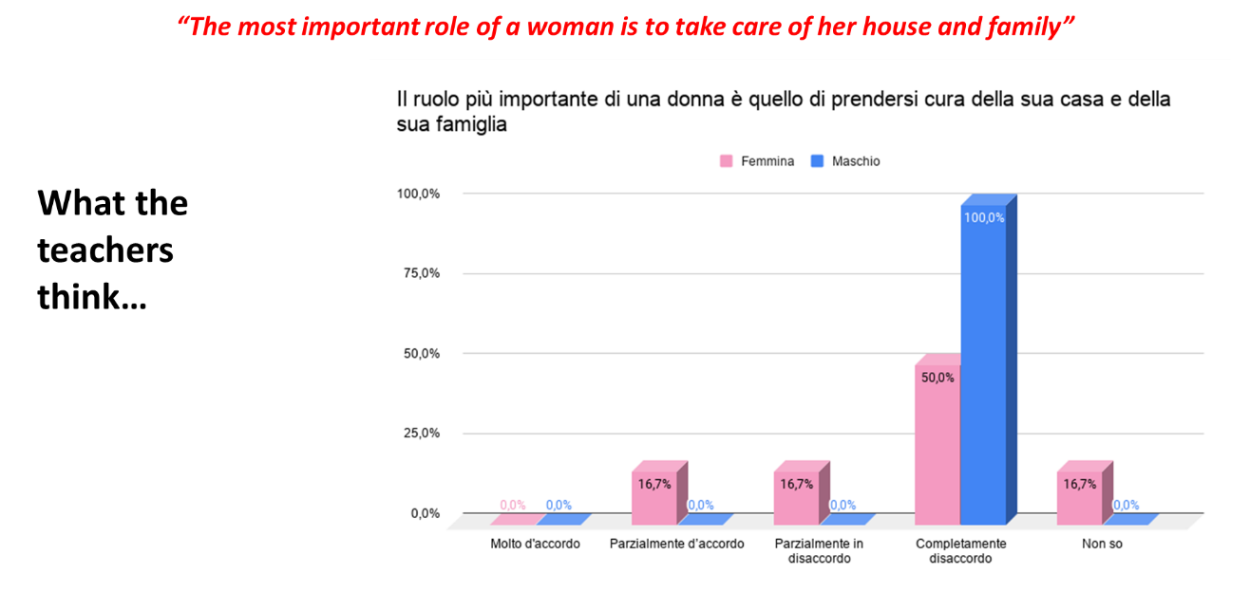
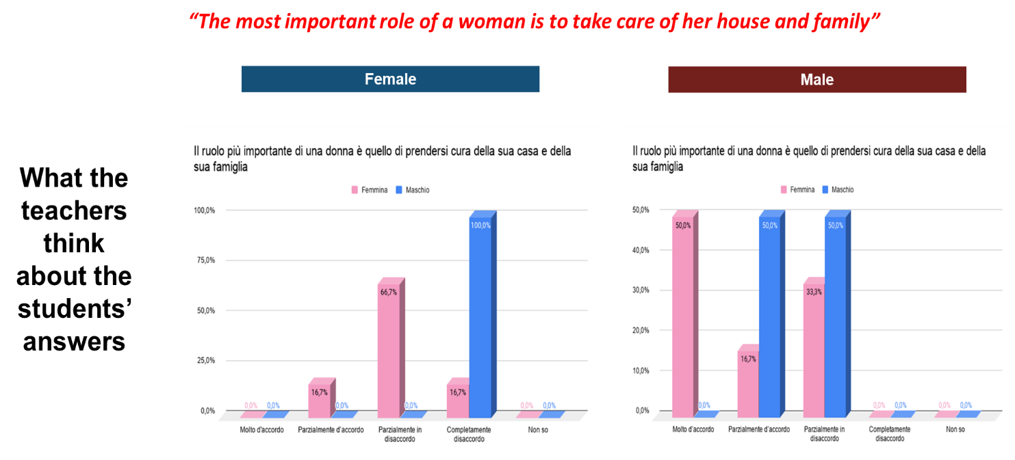
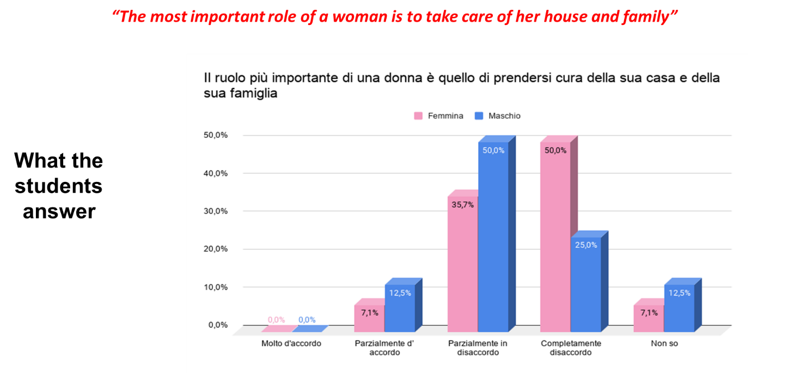
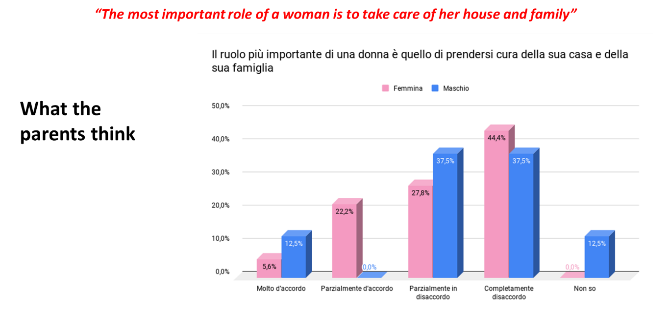

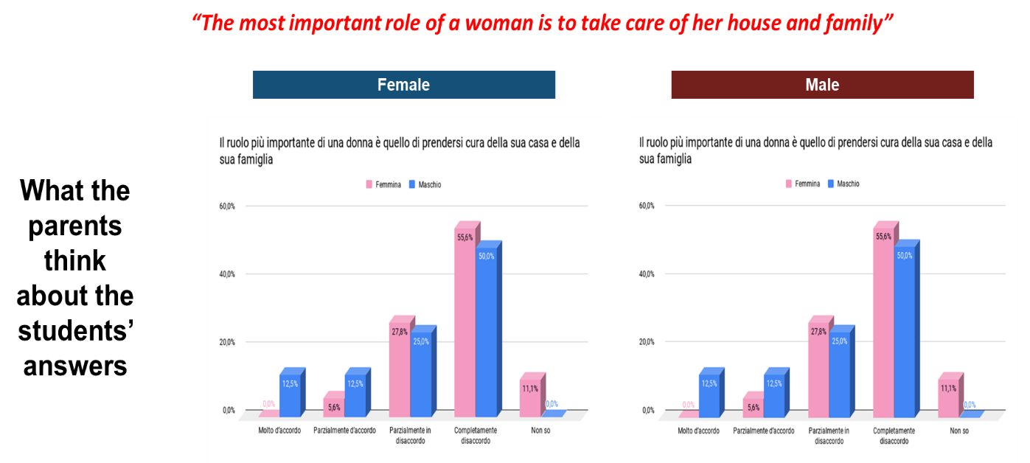

Liceo Augusto

From this first meeting with the students of the Liceo Augusto, of which we offer you a selection of the interventions, interesting points of reflection emerge both in terms of group dynamics and the relationship with gender differences and stereotypes related to these.
In fact, we can say that these two aspects intersect giving rise to an interesting discussion both for the modality of communication itself and for the contents that are expressed.
The first important point to note is that males are the first to intervene in the discussion; this is an aspect that we also notice in other schools and that in general we notice whenever we offer training in schools. It is the males who immediately take a position and seem to have less difficulty in being present with their opinions and thoughts.
In this particular case there seems to be a student who expresses a position of dominant position with respect to the group and who continues to pursue his thesis in spite of all the objections and contrary all the objections and contrary evidence that is being challenged. Anchored to the concept of "male" as something "biological" that finds its reason in "being naturally brought by nature", there is nothing and no one who can scratch his thought that he continues to pursue even though at a certain point he says: "I don't know anything about genetics!". His position in the group however does not change: he remains He remains the interlocutor to interface with, he is somehow the leader to convince. As if the group dynamic had given him leadership in the conversation.
In addition to this point, it is interesting to note the attitude of the boy: so caught up in the prejudice of the division between men and women on the basis of genetics he is not open to any possible genetics he is not open to any possible change of mind despite the fact that he is provided with discordant studies and experiences discordant with his position are provided. We note here one of the consequences of the use of stereotypes in the approach to knowledge: the potential for distortion of reality due to the rigidity and impermeability of one's own conceptual system even in the face of the disconfirmations of experience.
On the other hand, what happens in girls? When females timidly take up words they initially do so in a more "weak" manner mostly by asking questions of the aforementioned student, that is, by trying to arouse doubt in him but never by clearly stating a thought. To arrive at a first statement of a clear opinion we have to wait until the 10th minute of the recording that we have proposed.
Unlike males, females seem to have more difficulty greater difficulty in asserting a clear and unquestionable position of their own. In the second part of the meeting, to continue exploring the culture of the group of students, I propose an exercise: associate the first word that comes to their mind when thinking about the word "male" and "female". Here, too, it is important to note how a small group of girls, by the way silent throughout the discussion, decide not to take the floor. The goal of the exercise was to be able to work on the emotional, therefore unconscious, dimensions associated with gender without them being mediated and misled by thought, which as such is intentional and conscious. The words associated with masculinity AND feminity were:
MASCULINITY | FEMINITY
BLUE | THERE MUST BE MASCULINE
NORMAL | BALANCE
MODERATE | DIFFERENT SEX
GENRE | FERTILITY
STEREOTIPED | RESPONSIBILITY
NOT FREE | DELICACY
IMPONENT | THINKING
MAN | SENSUALITY
VIRILITY | BEHAVIOUR
PREJUDICE | GROWTH
BALL | HELPING ONESELF
LOVE EACH OTHER | RELIEF
THINKING | SWEETNESS
AUTHORITY | PREJUDICE
DIFFERENT SEX | MATERNITY
FEMININE | SENSITIVITY
 | ACTING LIKE A YOUNG LADY

In asking the group what they thought about these different words, one student put forward an interesting hypothesis: with respect to the feminine, there was more freedom to associate, more adjectives are present that tell about the female than the male. This is a hypothesis that circulated in the class and had already taken shape during the discussion: the role rigidity that is imposed on the male role model crushes personality within clear social expectations, such as clothing and behaviour.
The students grasped an important consequence of the use of stereotypes as instruments of knowledge, even if they attribute it only to males without grasping its universality: stereotypes simplify facts insofar as they propose to represent groups and not individuals: they then do not do justice to the specificity of individuals, who are assimilated into a global image. Interesting that they consider women to be freer!
The words that seem to convey a power relationship with the other, such as relationship of power with the other, such as "set" "Imposing" "Authority" "Virility", whereas the words that seem to convey a relationship of power with the other are not. "Virility", whereas in the feminine list we find mostly terms that take into consider the ability to care and grow of the maternal function, "fertility" "responsibility" "motherhood" appear; those divisions seem to return divisions related to masculinity and femininity that date back to the Industrial Revolution of the eighteenth century in which Revolution of the eighteenth century in which the masculine was attributed strength, courage and desire to while the feminine implied gentleness, patience and maternal instinct.

Liceo Terenzio Mamiani

From the meeting with the students of the Liceo Mamiani the results were different: they are in fact students used to talking to each other, they hardly interrupt each other, they listen to each other and they are used to expressing opinions about the topic at hand. With respect to our intervention, probably the presentation of Telefono Rosa as an association that fights against violence against women, pushed them immediately to focus on the theme of gender violence. It is striking how many stereotypes exist in this sense: violence motivated by madness or by an "access" of uncontrolled rage from a psychopathological state of mind, stereotypes that seem to "calm" or "justify" what could seem to be an accusation of the male gender! Having refuted their opinions from the association's thirty years of experience, they moved on to consider the cultural dimension of the problem of gender violence.
However, the problem seemed to be an individual one: culture understood as "what you are taught" by your parents, not as a symbolic dimension shared by the people who share a context; in this sense, it is necessary to question the ways in which the cultural dimension is shared by the people who share a context.
this sense we need to question the ways in which we look at events, the words we choose to do so. What is noticeable is the great attention that everyone pays to not making mistakes, as if they were worried about saying something unintentionally. One very significant moment stands out: the students, in questioning how culture "allows" or establishes roles, talk about the possibility of males crying in public in the same way as females.
One boy, who was trying to argue for gender equality, in arguing stumbles into a "mistake" himself by arguing that "in a family structure there is still a need for a strong shoulder on which to cry, precisely because these types of figures must remain"; the student himself stops himself exclaiming, "Oh God what have I said?".
This example seems particularly significant to us for two orders of reasons: it confirms our our hypothesis that gender stereotypes are often unconsciously conveyed and can be detected simply by the type of words we use in our everyday language. The second reason that makes this moment noteworthy is that it underlines again how the strong side of the couple and the family must necessarily be the male one. Precisely because they are harbingers of the way we look at the concept of gender itself, the students were asked to associate words with "male" and "female", asking them to write them down on a piece of paper and also note the gender of the person writing to see if this variable could have any influence on the final effect.

WHAT THE BOYS HAVE WRITTEN ASSOCIATING TO THE WORD MALE
GIRLS | BOYS
Cowordice | Penis
Manhood | Beard
Irrational | Tall
Instinctive | Worker
Man | Man
Autonomy | Shirt
Dominant | Person
Strange | Testosterone
Self-centered | Macho
Insensible | Manly
Manly | Indipendence
Father | Proud
Provident | Strong
Protection | Authoritarian
Comfort | Jealous
Honour | Insensible
Strong | Weakness
Maturity | Desire for power
 | Family
 | Expectations
 | Duties

The substantial difference between the two lists of words consists in the presence, in the words associated by the boys, of a series of adjectives that recall precisely the physicality of the male gender: beard, testosterone, penis. male gender: beard, testosterone, penis. A clear idea of what the male must be like, an idea that also recalls the objective relevance of certain distinctive elements of gender. As far as the other associations are concerned, there are no particular differences in those chosen by girls rather than boys, confirming that stereotypes are often transversal and shared.
WHAT STUDENTS ASSOCIATED WITH THE WORD FEMALE
GIRLS | BOYS
Emotional | Long Hair
Sweetness | Diligent
Power | Responsible
Complicated | Woman
Good | Female
Calm | Children
Fragile | Person
Sensitive | Graceful
Authoritarian | Children
Delicate | Love
Wise | Emotional
Pink | Understanding
Strong | Vain
Love | Beautiful
Multitasking | Meek
Weak | Superior
Understanding | Cool
Maturity | Romantic
 | Fragrance

With regard to the words associated with "female", there do not seem to be great differences in the quality of the words used in the two groups.
Basically, reference is made to canons of femininity that have to do with the emotional dimension of welcoming and understanding; it is striking that girls represent themselves more in these dimensions.
The word "complicated" was used three times.
Complicated derives from the Latin “complicare”, and indicates something bent, wrapped around itself. A problem is complicated when it presents itself as the result of a set of parts that are difficult to encode. What is complicated can be reduced to something simpler. Complicated is anything that requires unnecessary effort, where we perceive the need for a waste of time and energy to deal with what could be reduced to something far simpler. With this way of looking at it, femininity appears to be reduced to something as yet nor deciphered but decipherable rather than something complex which as such is composed of a multiplicity of interdependent parts (Complexity derives from the Latin complexus, interwoven). In short, it appears to be a vision of a woman whose identity dimensions are undervalued. In order to work further on students' associations, one can consider the three motivational areas that McClellan (1985) identified as foundational to social relationships: Affiliation, Power and Success. Affiliation motivation aims to evoke an attitude of self-acceptance and self-responsibility in the relationship.
The motivation to affiliation aims to evoke an attitude of acceptance and taking charge of oneself and one's emotional dimension. Affiliation consists in seeking, establishing and maintaining interpersonal relationships of friendship and intimacy.
Those who have a strong need for affiliation tend to avoid situations of conflict and to assume accepting attitudes. Power motivation implies a tendency to control, determine, influence the behaviour of the other person in the relationship, conditioning the behaviour of the other person. The power motivation implies a tendency to control, determine, influence the behaviour of the other person in the relationship, conditioning the decisions that underlie the relationship and its development. relationship and its development. The need for power consists in the aspiration to occupy positions of command, to have control over things and people or to possess objects that indicate a superior social position. superior social position. The motivation to succeed involves the aspiration to achieve tasks and objectives that are out of the ordinary, to measure oneself against the parameters of excellence. It consists of the search for affirmation, perfection and excellence.
Those who are motivated by this need tend to set high but realistic goals. Looking back with these categories at the lists of adjectives used by the students we notice how those associated with the female gender are predominantly within the area of affiliation (with (with words such as emotional, sensitive, sweet, wise, calm, understanding) while for the male masculine are mainly used words that refer to the area of power (strong, authoritarian, responsible, dominant, egocentric, autonomous). Both lists present to a lesser extent adjectives of the other area, that of power for females and of affiliation for males, absent for both is the motivational area of success. This absence seems relevant to us because when one feels "crushed" by stereotypes, it becomes difficult to experience that "third" that looks at objectives and realises products.

5. Conclusions

The methodology developed by Telefono Rosa focuses its operational premise on the synergy activated between young people, teachers and parents, and the results obtained have shown how a more aware view of gender stereotypes can be developed through the administration of questionnaires, subsequent reflection and dialogue with the parties involved in the project. The aim of this phase of the project was therefore to begin to build a new awareness of gender stereotypes and a critical capacity to identify invisible stereotypes. The result of the new awareness achieved shows that the way forward is the right one.

Report on Eliminating Gender Stereotypes in the EU, the European Parliament, 2012
Special Eurobarometer 465 – Wave EB87.4 – TNS opinion & social Gender Equality 2017 Report Fieldwork June 2017 Publication November 2017. The questionnaire asked to respondents those questions: Please tell me whether you agree or disagree with each of the following statements. 1.1 It is acceptable for men to cry; 1.2 Women are more likely than men to make decisions based on their emotions; 1.3 The most important role of a man is to earn money; 1.4 The most important role of a woman is to take care of her home and family.

